 

**AggieSAT LAB - Texas A&M University Engineering**

**Team Perseus**



**AIAA Team Space Design Competition 2020-2021**

**Team Members:** Andrea Rivera, Santiago Garza, Samuel Moore, Nicholas Siodlarz, Abigail Rajagopal, Elena Welch, Luke Bedrosian, Antonio Ruiz, Garrett Moore

**Faculty Advisor:** Dr. Helen Reed

|  |  |  |  |
| --- | --- | --- | --- |
| Member | AIAA # | Member | AIAA # |
| Team Lead    Andrea Rivera | 1229924 | Santiago Garza | 1229906 |
| Samuel Moore | 1229974 | Nicholas Siodlarz | 1241718 |
| Abigail Rajagopal | 1241504 | Elena Welch | 1230545 |
| Luke Bedrosian | 1179795 | Antonio Ruiz Nuñez | 1241702 |
| Garrett Moore | 1241714 | Faculty Advisor: Dr. Helen Reed |  |

## 

## List of Acronyms

|  |  |
| --- | --- |
| AIAA | American Institute of Aeronautics and Astronautics |
| NASA | National Aeronautics and Space Administration |
| MRO | Mars Reconnaissance Orbiter |
| ISRU | In Situ Resource Utilization |
| RFP | Request for Proposal |
| DDT&E | Design Development Test and Evaluation |
| LOI | Letter of Intent |
| WBS | Work Breakdown Structure |
| CONOPS | Concept of Operations |
| TCM | Trajectory Correction Maneuvers |
| DSN | Deep Space Network |
| EDL | Entry, Descent, Landing |
| SROI | Science Region Of Interest |
| RROI | Resource Region Of Interest |
| CDH | Command and Data Handling |
| RTOS | Real Time Operating System |
| SSDR | Solid State Data Recorder |
| EDL | Entry, Descent, and Landing |
| TRN | Terrain Relative Navigation |
| UHF | Ultra-High Frequency |
| MAV | Mars Ascent Vehicle |
| RTG | Radioisotope Thermoelectric Generator |
| WSS | Wheel and Suspension System |

List of Acronyms 2

**Preface and Introduction:** **5**

1.1 Background: 5

1.2 Executive Summary: 5

1.3 Mission Description: 8

1.4 Project Scope and Deliverables: 8

1.5 Disciplines Required: 9

**2. TakeOff to Mars:** **13**

2.1 Chosen Launch Date 13

Figure 2-1-1. Trajectory Contour Plot. 14

Table 2-1-1. Energy Minima for 2026 15

2.2 Launch Vehicles: 15

2.3 Cruise Phase: 17

2.4 Entry to Martian Orbit 20

**3. Landing Site Selection:** **20**

3.1 Introduction: 20

3.2 Regions of Interest: 21

SROI-1: 22

SROI-2: 22

SROI-3: 23

SROI-4: 23

3.3 Location Selection: 23

3.4 Future areas of interest: 24

**4. Entry, Descent, and Landing (EDL)** **24**

**5. Rover** **27**

5.1 System Overview: 28

5.2 Command and Data Handling (CDH): 32

5.3 Electric Power System (EPS) 34

5.4 Communication System (COMMS) 37

5.4.3 Ultra-High Frequency Antennas: 41

5.4.4 System Data Rates 41

5.4.5 COMMS Components List 42

5.5 Guidance, Navigation & Control (GNC) 42

5.7 Sample Caching System 52

**Figure 5.6.2.1 CAD Renderings of the ROPEC Drill** **54**

**Figure 5.6.2.2 Diagram of Hybrid Drill Bit Design** **56**

5.8 Wheel and Suspension System 62

5.9 Rover Body 65

**6. Mars Ascent Vehicle (MAV)** **67**

6.1 System Overview and Subsystem Requirements 67

6.1.3 System Risk Verification and Matrix 69

Table 6.1.2: MAV Risk Matrix 70

6.2 Electrical Power System (EPS) 71

6.3 Communications 72

6.4 Guidance, Navigation, and Control 73

6.5 Payload and Main Components 76

6.5.1 Main Components 76

**7. Orbiter** **78**

7.1 System Overview and Subsystem Requirements: 78

7.1.2 Orbiter Concept of Operations: 80

7.2 Propulsion 82

7.3 Electrical Power System 85

7.4 Communications 86

7.5 Attitude Determination and Control System 86

# Preface and Introduction:

## 1.1 Background:

The National Aeronautics and Space Administration (NASA) and international partners are constantly focusing on expanding human space exploration into understanding interplanetary unknowns and explaining the origins of Earth. Surface Mars missions such as the recent landing of Perseverance on Mars address the primary goal of deepening the understanding of whether life ever existed on Mars by searching for evidence of ancient habitable environments where microbial life could have once existed. Previous Mars rovers and scientific instruments such as the Mars Reconnaissance Orbiter (MRO) and the Mars Odyssey Orbiter (MOO) have analyzed the Mars subsurface to locate water ice and further critical Martian In Situ Resource Utilization. In order to one day possibly establish a human presence outside of Earth and further human exploration, it is imperative to analyze the Martian surface for life sustaining elements. Identifying these indicators for the presence of present or past life forms will put humanity one step closer to becoming a multiplanetary species.

Through In Situ Resource Utilization (ISRU), Martian water can be broken down into hydrogen and oxygen to make propellant. One day, Martian water can be used as regular drinking water. This will minimize payload, decrease cost of future space exploration missions, and reduce the transport of resources from Earth to Mars. Analyzing these Martian ice deposits opens the possibility to sustaining life and paves the way for future human space exploration missions to the planet.

## 

## 1.2 Executive Summary:

Team Perseus has designed a mission to find ice core samples and bring them home to Earth. With both respecting existing technology and reinventing others, Team Perseus provides a method for humanity to explore the Martian surface. Similar to the *Spirit* and *Opportunity* missions, the Perseus mission will employ a lander. However, since a form of ascent must be used, which contains volatile fuel, the form of landing employed in these missions would not be optimal for the Perseus mission. Instead, the Perseus mission will combine the *Spirit* method of EDL with the *Curiosity* method of EDL, using a skycrane. Before entering the Martian atmosphere, the lander will contain the rover and the MAV, attached to its inside, and will be in cruise stage configuration. Once the cruise stage enters the Martian atmosphere, the heat shield will protect its descent until a critical altitude, at which point supersonic parachutes will deploy and the heat shield will drop to the surface. During this entire endeavor, thrusters in the upper shell of the cruise stage will make trajectory corrections to ensure that the payload is delivered to the planned area of research. Once the cruise stage is close enough to the surface (about 2 km), the descent stage will be released, with retro thrusters on the descent vehicle firing to slow down it and the connected lander. Once the pair reaches close enough to the surface, a cable will slow drop the lander down to the surface. After the lander reaches the ground, the cable will be released, and the descent vehicle will fly off to crash land a safe distance away from both the lander and the research site.

Analyzing the mission prompt, in its demand for ice cores of a specified length and diameter, it is clear that an automated device must be used to drill such samples from the Martian surface. What’s more, this device must be capable of either removing the cores from the surface itself or transferring the cores to something that will. The device that best mitigated the risk of such a mission is the rover, due to its repeated testing, developed precision, and advanced technology.

In developing the rover, inspiration was drawn from the two most recent NASA rovers, *Curiosity* and *Perseverance*. Though many features unique to these two missions were removed, such as the MOXIE instrument, the masts, and several cameras and microphones, there are a plethora of others that were carried over into the Perseus mission. Inspiration was drawn from the design of *Perseverance* in the design of the rover structure and power systems, and the development of Perseus’s drill system found its origins in *Curiosity*’s. To say the least, existing technology was both revered and reimagined in the development of the Perseus rover.

The Perseus rover itself contains five main subsystems: Structures, CDH, EPS, COMM and GNC, each contributing to an important role in the ice sample return. The structure subsystem focuses mainly on the material protecting the rover and ensuring that the vehicle remains structurally intact and functioning over the course of the mission. This is the motivation behind the studies of the rover body, wheels, and suspension. In addition, the subsystem has an additional task of ensuring that the ice cores remain in their solid state and are safely transferred out of the rover. The CDH subsystem is responsible for the computers on board the rover, making sure that they are analyzing data correctly, and properly managing the basic functions of rover life, such as moving, sleeping, and waking. The EPS subsystem is responsible for the power being supplied to the rover. It contains batteries, solar panels, and generators that provide life so that the rover can complete its mission. The COMM subsystem, as implied by its name, involves the communication of data and instructions between the rover, orbiter, and Earth. Finally, the GNC subsystem is responsible for the navigation of the rover on the Martian surface, involving trajectory control and path planning.

Once the rover touches down on the Martian surface and the lander encasing it unfolds, the rover will power up and roll off of the lander to traverse the designated research area, SROI-1. During the time until September 2028, the rover will collect ice cores such that it will attain the required mass of 2.5 kg. In order to collect the ice cores, the rover will use a drill in order to ensure that the ice cores have the correct dimensions. After a core is drilled, the rover arm will then pick up the ice core, and put it into the sample container. The sample container, with a built-in Freon cooling system will ensure that the ice cores remain cold enough. Once the Earth return launch date approaches, the rover will then travel back to the lander where the MAV is located. When there, the rover will use its arm to take the sample container and place it in the MAV. Once this is done, the lander will then retract the petal the MAV is on so that it is in the correct position for launch.

For sample delivery from the surface of Mars to the orbiter, a Mars Ascent Vehicle rocket will be required and carefully designed to ensure secure sample processing. However, because of its autonomous nature, the precisions of the ascent and orbiter rendezvous procedures will be critical. As a result, the main function of the MAV was limited to sample retrieval and storage from the rover to the end of the mission.

Because of the delicate nature of the samples, the MAV was designed to ensure little to no levels of contamination on the samples including physical and thermal. Consisting of 2 propulsion stages and a sample storage unit, the MAV is a small but efficient machine. Using solid and liquid rocket propellants for Stage 1 and 2 respectively, the accuracy of necessary altitudes and velocity vector components can be achieved easier. Due to the liquid rocket stage, the angle orientations occurring at certain altitudes can be controlled and corrected easier since pressurized air will be used to provide the necessary torque to change the orientation of the vehicle. Additionally, if it is determined that the velocity of the MAV becomes too high at certain points along the stage 2 ascent, especially near the orbit altitude, the liquid rocket can temporarily deactivate, and stop providing thrust for some necessary time interval.

The exterior of the MAV has been designed with an aluminum alloy to provide protection but lightweight material for the structure. Originally, the MAV was going to be placed on the exterior of the orbiter resulting in large amounts of carbon-carbon composite to serve as a heat shield and external shield for all the MAV structures and the ice samples. However, because of the change to a capsule transit form, the heat shield was no longer needed and an aluminum alloy reduced both the cost and mass of the MAV. The MAV’s stage 1 will detach once Stage 1 engine cutoff occurs, resulting in a smaller initial mass for Stage 2 propulsion. 2 tanks will be used for the liquid propellant since the risk of using too much propellant before reaching certain checkpoints along the ascent is higher with 1 tank. Stage 2 of the MAV will stay attached to the sample storage unit to provide higher room for the arm of the capsule to grip when rendezvous occurs. The MAV will stay attached to the capsule arm for the duration of transit and capsule entry into the Earth and reduce the presence of significant vibrations by utilizing the rubber interior of the capsule claw. Physical contamination of the samples will be further reduced since the MAV will not be floating inside the capsule and no bouncing or continuous movement will occur.

The orbiter is tasked with transporting the rover, lander, and MAV to Mars, providing communications between the rover and Earth, providing aerial support for the rover, and rendezvousing with the MAV to take the samples back to Earth. Given the short time frame of the mission, the orbiter is tasked with providing quick, efficient interplanetary transfers, and will use a chemical propulsion system to provide quick delta-V changes to accomplish these transfers, which include the insertion into Martian orbit, leaving Martian orbit, and the insertion back into Earth orbit. These transfers will all be accomplished without the use of an aerobraking technique, which increases the risk of catastrophic damage to the systems. The orbiter is also equipped with multiple communication bands to relay data and information between ground support and the rover through the Deep Space Network, much like the current Mars Reconnaissance Orbiter. The orbiter is also capable of communicating with the MRO in order to use its more sophisticated instruments to help observation of the rover. In this way, some money is saved by not including cameras on the orbiter that the MRO already has. Onboard the orbiter is the capsule in which the MAV will be stored during Mars to Earth transit and the Lander including the MAV and rover will be stored from the Earth to Mars transit. Once the capsule captures the MAV using its arm, the MAV will be stored on the arm the entire time as stated above. The arm’s rubber interior will keep the MAV from slipping as well as preventing any significant vibrations. Once the desired altitude above the surface of the Earth is reached, the capsule will detach from the orbiter similar to the SpaceX/ISS undocking maneuvers. During the descent the heat shield will be used to protect both MAV and the samples from the intense heat. Once an altitude of 50 km is achieved, the capsule will deploy its parachutes from the top and slow the capsule down to a 20 mi/h velocity for an ocean touchdown. A landtouchdown is not expected and the orbiter will orbit around the Earth until an ocean or body of water is available for touchdown. The samples will be retrieved from the MAV and capsule by humans.

## 1.3 Mission Description:

This proposal and mission is a response to the Request for Proposal (RFP) for the American Institute of Aeronautics and Astronautics (AIAA) Team Space Design Competition. The RFP seeks innovative ideas and engineering designs to return Martian ice core samples to Earth to aid in future analyses and design for space innovations and provide valuable insight about past or present life presence on Mars. The RFP seeks a detailed and unique mission design of a robotic system that lands on the Martian surface, identifies, locates and navigates to Martian ice deposits, retrieves ice core samples, and returns them back to Earth for further analysis. The mission design complies with the competition’s rules that encourage the use of concepts and technologies from previous programs as well as current NASA technology.

## 1.4 Project Scope and Deliverables:

The competition entails defining the end-to-end mission operations that include launch, transit to Mars, entry/descent/landing, surface operations, ascent, and return to Earth to successfully complete the mission of Martian ice core retrieval within the given cost and schedule constraints. The cost constraint is that the end-to-end mission shall not exceed $1 Billion US Dollars including launch, design, development, test, and evaluation (DDT&E), and flight unit costs. The given time constraint is that the ice core samples must be returned to Earth for analysis by December 31, 2030. Other constraints include returning a minimum of 2.5 kg of ice core samples back to Earth with samples being at least 25 mm in diameter and 100 mm in length and the robotic system being able to store the ice cores in a frozen state during surface operations and upon its return back to Earth laboratories for examination.

Project deliverables include official documentation comprising a Letter of Intent (LOI) by February 12, 2021 and a Final Proposal submitted by May 14, 2021. The final proposal shall consist of an extensive executive summary, requirements definition, concept of operation (CONOPS), trade studies, design integration and operation, cost estimate including Work Breakdown Structure (WBS), schedule, and references. The design of all subsystems will be provided along with a dedicated summary table showcasing the mass and power budget broken down by each system.

## 1.5 Disciplines Required:

Team Perseus includes personnel from aerospace engineering and computer science disciplines. However, this project will incorporate multiple disciplines and effectively leverage systems engineering through the duration of development, integration, verification and validation of all subsystems. Per AIAA guidelines, additional disciplines include structures, propulsion, flight mechanics, orbital mechanics, thermal, electric power, attitude control, communications, sensors, environment control, and systems design optimization.

**1.6 Mission Overview and Timeline:**

The following diagram shows Team Perseus’ mission overview from launching aboard the chosen Falcon Heavy rocket to the sample return back to Earth.

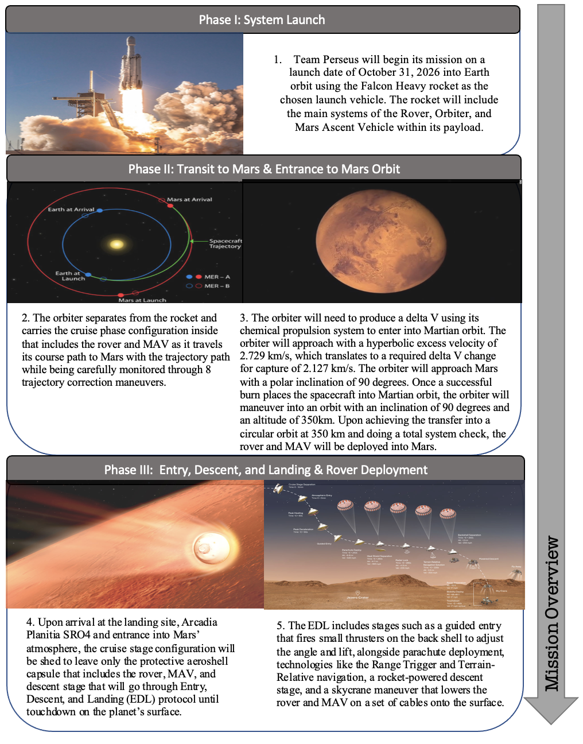

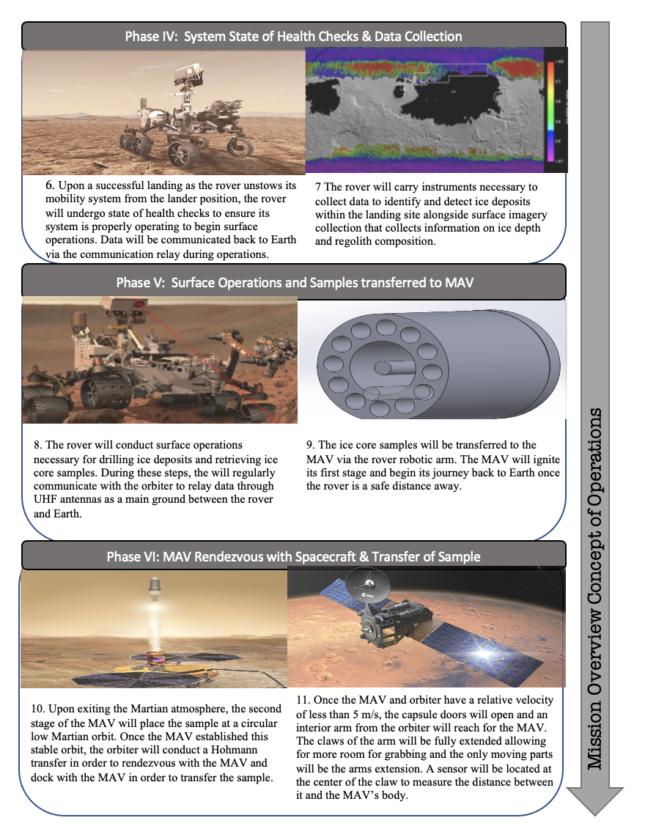

## 

As will be mentioned later, the anticipated date for launch from Earth will be October 31, 2026 with a landing on Mars on August 19, 2027. This gives 9 months and 19 days for travel in the cruise phase between Earth to Mars. These 9 months will be the least energy required for travel. The Entry, Descent, and Landing will happen within a day of arrival as the rover and MAV are separated from the orbiter after it achieves the transfer into a circular orbit. State of health checks will last for the following 10 days. These state of health checks will ensure operations for the rover and MAV run smoothly upon landing. This phase will confirm the systems’ exact location on Mars and will initiate the base functions of different subsystems. Around 5 of those 10 days will be used to transition from the software the rover uses to land during the EDL phase to the software needed for surface operations. Surface operations will be the next phase, lasting around 12 months and 6 days, which leaves time for collecting ice core samples. During this phase, data is transmitted back to Earth about rover operations on the Martian surface including meteorological data, chemical surface composition data, and ongoing state of health checks. The last phase will be the sample return trip to bring the collected samples back to Earth from Mars. This return trip will last 11 months and 6 days to align with the 2028 Mars-Earth trajectory departure and arrival dates that will be mentioned later.

**Table 1-6.** Timeline of key mission events.

|  |  |  |  |
| --- | --- | --- | --- |
| **Phase** | **Definition** | **Start Date** | **End Date** |
| Launch | Lift-off from Earth via the Falcon Heavy rocket. | October 31, 2026 |  |
| Cruise | Journey to Mars upon separating from the rocket. | October 31, 2026 | August 19, 2027 |
| Approach | 45 days from entry into the Martian atmosphere. | July 5, 2027 | August 19, 2027 |
| Entry, Descent, Landing | Journey from entry into Martian orbit to landing on the surface. | August 19, 2027 | August 19, 2027 |
| State of Health Checks | Conducting tests to ensure the system is in a safe state to proceed operations. | August 20, 2027 | August 30, 2027 |
| Surface Operations | Day-to-day activities with the goal to collect and retrieve ice core samples. | August 30, 2027 | September 05, 2028 |
| Sample Return Trip | Journey to return samples in their frozen state from Mars to Earth. | September 05, 2028 | August 11, 2029 |

# 2. Take Off to Mars:

## 2.1 Chosen Launch Date

Earth departure should occur when Earth is in conjunction with Mars. The primary launch date to Mars is October 31, 2026. The amount of energy required to travel to Mars is lower on this date than any other in 2026 due to Mars moving into optimal position with Earth 10 months later, at the arrival date of August 19, 2027. A return trip to Earth will start in September of 2028.

#### **Figure 2-1-1.** Trajectory Contour Plot.

Figure 2.1.1 shows the contour plot for 2026 departure dates. There are two optimal values shown in the plot, these two represent Type I or Type II trajectories, the bottom being Type I and the top being Type II. Energy minima up to 50 ${km}^{2}/sec^{2}$ are shown, as weather or other issues may cause delay in launch. Type I trajectories have shorter trip times and Type II have longer trip times but are less susceptible to error. The energy minima shown in the plot is summarized in Table 1 below. Any of the dates would work; October 31st was chosen for being the smallest energy value of the year, and for being a Type II trajectory that has less error. In the assumptions for these calculations is an exit from a 407 km circular parking orbit, with an inclination of 90° degrees. Although the data is for ballistic trajectories, the orbiter has maneuverability after launch. Deep-space maneuvers may be necessary during transit, and will be necessary to transfer into and out of the Martian orbit.

#### **Table 2-1-1.** Energy Minima for 2026

As a precautionary measure, a secondary range of launch dates is designated in case of any major delays or conflicts that may arise during mission development. This range of dates occurs roughly two years after the primary range of launch dates and has a lower average energy minimum than the range in 2026. However, given the time constraints of the mission, a Type 1 trajectory will best suit the secondary mission launch range. Of the dates in this launch window, the December 10, 2028 date is the optimal launch date with January 17, 2029 being the last chance for launch. These two dates enable an earlier arrival date than the other Type 2 trajectories while maintaining a minimal energy requirement. The two optimal dates for both Type 1 and Type 2 trajectories are summarized in the table below. The first of the secondary range of launch date results in arrival at Mars on July 20, 2029, leaving a ground time for the rover of 9 months to search for and collect samples.

**Table 2-1-2.** Energy Minima for 2028.

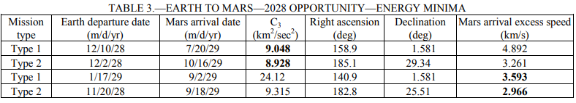

## 2.2 Launch Vehicles:

The selected launch vehicle for the mission is Space X’s Falcon Heavy, the world’s most powerful commercial rocket. A trade study was conducted to provide the most accurate comparisons of launch vehicles considered for the mission ranging from launch cost, payload to LEO, payload to GTO, mass and number of previous launches. One of the main reasons for choosing the Falcon Heavy despite the low number of previous launches is the innovative technology behind the rocket. The Falcon Heavy is composed of the three Falcon 9 nine-engine cores and has a Payload to Mars of 16,800kg (37,040lbs) compared to the closest competitor for a launch vehicle, the Falcon 9 which has a Payload to Mars of 4,020kg (8,860lbs). The Falcon Heavy has more than twice the lift capability of any rocket currently on the market. Although the Falcon 9 is an attractive option, the Mars mission will include a heavy payload which combines all three main subsystems of rover, MAV, and orbiter in one launch to maximize cost efficiency. When calculating the payload launch cost to Mars, the Falcon Heavy exceeds at $5,357k per kg to Mars versus its closest competitor the Falcon 9 at $15,422k per kg to Mars. When compared to other government rockets, the Falcon Heavy is extremely cost efficient and phenomenally less expensive.

**Table 2-2-1.** Depicts the launch vehicles analyzed for possible selection.

|  |  |  |  |  |  |
| --- | --- | --- | --- | --- | --- |
| **Rocket** | **Launch Cost**  **($M)** | **Payload to LEO**  **(kg)** | **Payload to GTO**  **(kg)** | **Mass**  **(kg)** | **Number of previous launches** |
| Delta II 7925 | $51 | 2,800-6,140 | 1,140-2,190 | 152,000 - 286,000 | 155/ Retired |
| Atlas V 401 | $109 | 8,250-20,520 | 4,750-8,900 | 590,000 | 38 |
| Atlas V 541 | $145 | 17,443 | 8,290 | TBD | 6 |
| Starship | $2 | 99,790.3 | 20,865.3 | TBD | In development |
| Falcon 9 | $62 | 22,800 | 8,300 | 549,054 | 111 |
| Falcon Heavy | $90 | 63,800 | 26,700 | 1,420,788 | 3 |
| New Glenn | TBD | 45,000 | 13,600 | TBD | In Development |

The Falcon Heavy’s predecessor, the Falcon 9’s family, has shown a success rate of 98% with 115 launches in the past 11 years resulting in 113 full missions and only 2 failures. Despite having only 3 launches, the Falcon Heavy has had a 100% success rate within its previous mission. The build time for the Falcon Heavy is around 12 weeks and maximizes the likelihood of reaching the desired end-to-end mission deadline within the time constraints.

**Table 2-2-2.** Overall System Mass Budget.

|  |  |  |
| --- | --- | --- |
| **Cost per launch** | **Mass Payload to Mars Transfer Orbit** | **Total Mass carried from all systems** |
| $90 million | 16,800 kg (37,000 lb) | 9000 kg |

## 2.3 Cruise Phase:

The journey to Mars begins as the second stage executes the transfer burn. The trip to Mars takes abouts seven months to traverse the distance of about 250 million miles. Team Perseus’ cruise path to Mars will utilize the existing technology and the cruise phase trajectory that has been utilized by NASA for all previous Mars rovers and missions, such as the MRO. An important objective throughout the cruise phase will be closely observing the spacecraft’s trajectory path to Mars to ensure the most efficient precision and angles to land on the moving planet’s orbit. Course corrections will be performed at different points of the cruise phase through eight Trajectory Correction Maneuvers (TCM). The burns that implement the TCM will be computed on the ground and uplinked to the spacecraft for execution.

**Table 2.3.1:** Cruise Phase Trajectory Correction Maneuvers.

|  |  |  |
| --- | --- | --- |
| **Date** | **Trajectory Correction Maneuvers** | **Activity** |
| **November 15, 2026**  15 days after launch | TCM-1 | State of Health Checks; Checking flight path after Launch |
| **December 30, 2026**  60 days after launch | TCM-2 |
| **February 28, 2027**  120 days after launch | TCM-3 | Attitude maneuvers and trajectory path corrections and checks |
| **March 30, 2027**  150 days after launch | TCM-4 |
| **August 9, 2027**  10 days before landing | TCM-5 | Refine flight path |
| **August 16, 2027**  3 days before landing | TCM-6 |
| **August 18, 2027**  1 day before landing | TCM-7 | Final chance to adjust trajectory |
| **August 19, 2027**  9 hours before landing | TCM-8 | Trajectories for entering Martian atmosphere |

The cruise configuration used for the mission will deploy the antenna and the solar arrays. A majority of the spacecraft’s structure consists of aluminum. The spacecraft generates power using its exterior solar panels, which are 2.65m in diameter and provide up to 600W of power on Earth and 300W on Mars. With cruise phase temperatures ranging from -250 $℉$ to 250 $℉$ the flight electronics must be carefully monitored to prevent overheating. The electronics are thermally stabilized using Freon loops that absorb heat from inside the spacecraft and reject it into outer space through heat exchangers and external panels. If at any point, the spacecraft senses a temperature out of its range, the spacecraft will automatically go into Safe Mode and wait for ground control to troubleshoot and resolve the problem. During the entire trajectory, avionics will communicate telemetry data back to engineers on Earth through the NASA Deep Space Network (DSN), an international network of antennas that provide communication links between Earth and Mars.

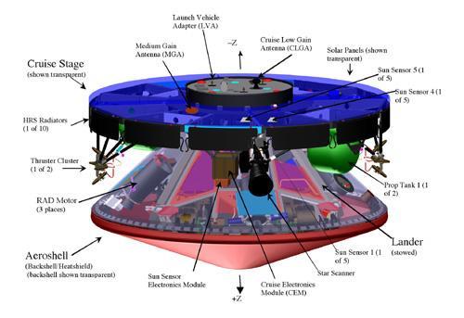

**Figure 2-3-1.** Cruise Stage System Configuration.

Attitude maneuvers are critical throughout cruise to maintain the communication antennas pointed towards Earth and the solar arrays facing towards the sun for power. Attitude determination is achieved through sensors aboard the cruise configuration that aid in providing complete information about the orientation of the spacecraft. A total of 16 sun sensors are used to track the sun’s position for proper alignment and star sensors to identify which way the spacecraft is pointing as well as an Inertial Measurement Unit (IMU) that is used for attitude determination in estimating position and velocity of the vehicle. Orbital determination is based on radiometric measurements from the Deep Space Network communication relay that includes two-way coherent Doppler ranging, and delta differences one-way ranging (ΔDOR). Communication data and the doppler effect explains where the spacecraft is headed and at what speed. The communication subsystem includes 2 X-band radio antennas on board for radio communication including a low gain antenna that communicates data as the spacecraft is closer to Earth and a medium gain antenna as it travels further from Earth.

During the course to Mars major operations are performed including health checks and maintenance of the spacecraft in its cruise configuration, monitoring and calibration of the spacecraft and various subsystems. Attitude correction turns are made to keep the antenna pointed towards Earth for communications and the solar panels pointed towards the sun for power. Different navigation activities are conducted such as trajectory correction maneuvers to determine and correct flight path before atmospheric entry.

## 2.4 Entry to Martian Orbit

The orbiter will need to produce a $ΔV$ using its chemical propulsion system to enter into Martian orbit. The orbiter will approach Mars with a hyperbolic excess velocity of 2.729 km/s, which translates to a required $ΔV$ change of -2.127 km/s for capture. Once a successful burn places the spacecraft into martian orbit, the orbiter will maneuver into a polar orbit at an altitude of 350 km.

# 3. Landing Site Selection:

## 3.1 Introduction:

The proper and thorough investigation and selection of areas of interest for landing sites is critical to the success of the mission. The landing site must provide the necessary features for the completion of the mission. Access to subsurface ice is the main consideration for landing sites. Additional factors include geographic features, latitude, terrain, and data available for the site.

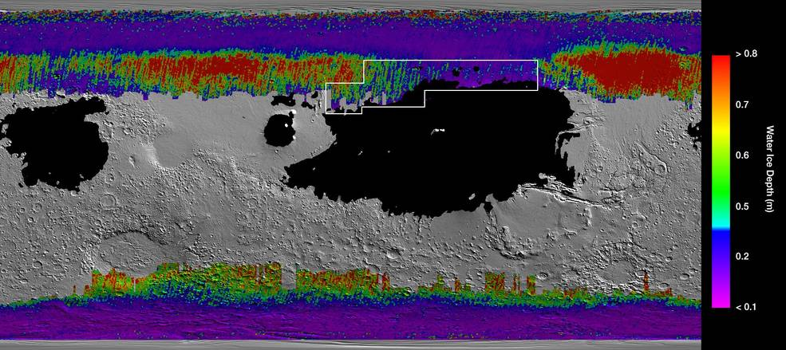

**Figure 3-1-1.** Map of Mars showing water ice depth.

## 3.2 Regions of Interest:

Regions of interest for this mission lie in the Northern, high latitude plains of Mars. See Figure 1. Specifically, in the 2200 Sq. Km region of Arcadia Planitia. Regions of interest can be found in a Diacria quadrangle of Arcadia Planitia, called Acheron Fossae. All four SROIs are within relatively close proximity with each other; however, separation between sites is still too great for the rover to reach multiple sites.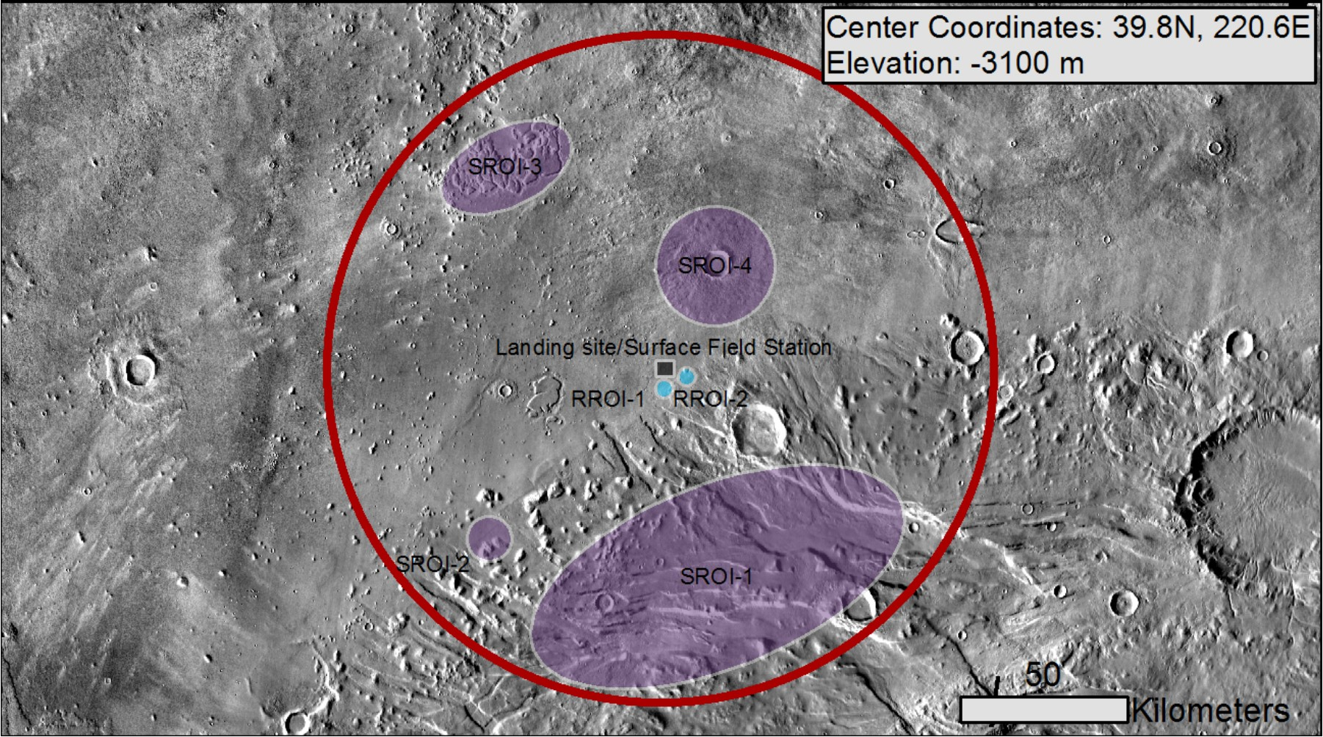

**Figure 3-2-1.** Map of Acheron Fossae.

Figure 2 above shows Acheron Fossae in Arcadia Planitia. Contained within the red circle are four SROIs (Scientific Regions of Interest) in addition to RROIs (Resource Regions of Interest). SROIs are chosen for their likelihood to produce scientific information if visited. Resource ROIs are chosen for their available resources. For this mission, only SROIs are of interest.

### SROI-1:

This graben system is the largest of the regions of interest located at 38.7°N, 221°E, within this region are several other points of interest. Positive aspects of this site are high latitude, access to Amazonian subsurface ice (Amazonian refers to a martian geologic period beginning 3 billion years ago and continuing to the present day), evidence of aqueous processes, potential for past habitability, potential for present habitability, near-surface ice, glacial or permafrost, well-covered in context camera (CTX) and, evidence of past tectonic activity. Context cameras give images of the broader area of interest.

Negative aspects of this site include relatively high levels of dust, potentially difficult to traverse terrain, and very little Compact Reconnaissance Imaging Spectrometer for Mars (CRISM) data. CRISM uses spectrometers to detect materials that indicate past and present signs of water.

Several regions of interest exist inside of SROI-1 however, they are separated by at least 20 kilometers. The distances between these sites introduce far too much risk to attempt to visit multiple sites. For reference the total distance traveled by the *Curiosity* rover, as of March 4th 2021, is 24.85 kilometers.

### SROI-2:

This channel-like surface feature is the smallest of the regions of interest located at 38.9° N, 219.5° E. It shows evidence of past aqueous activity and may have been habitable in the past. Positive aspects of this site are a high latitude, evidence of aqueous processes, potential for past habitability, potential for present habitability, near-surface glacial and permafrost ice, and is covered by CTX and HiRISE data.

Negative aspects of this site are high levels of dust, potentially difficult to traverse terrain, and very little CRISM data recorded.

### SROI-3:

This formation of large blocky mesas lies at 40.8°N, 219.6°E. Some positive aspects of this site are a high latitude, abundant subsurface ice, potential for present habitability, and adequate CTX coverage.

Negative aspects of this site are minimal HiRISE coverage, no evidence of aqueous processes, and very little CRISM data on record.

### SROI-4:

This impact crater is located at 40.8°N, 219.6°E. Positive aspects of this site are a high latitude, potential for present habitability, near-surface ice, glacial or permafrost, relatively little dust, and easy to traverse terrain.

Negative aspects of this site are only some HiRISE coverage, no evidence of aqueous processes, and very little CRISM data.

## 3.3 Location Selection:

The location that best fits the requirements for this mission is SROI-1. This location shows evidence of past aqueous activity, and possible past habitability. For this reason, this region will likely produce the most interesting results when analyzing ice samples. This region is home to several areas of interest however, the region as a whole is quite large, nearly 100 km in diameter, and most of it is not traversable by the rover. This means that we will have to localize our operations in a specific region of SROI-1.

## 3.4 Future areas of interest:

All of the previously mentioned SROIs would be intriguing to visit on future missions as well as Utopia Planitia. Utopia Planitia is a region in the northern hemisphere of mars. According to NASA, the region contains as much water as Lake Superior frozen underneath the surface. Acquiring ice core samples from this region would likely yield very interesting scientific data as it comes from a different area of the planet.

# 4. Entry, Descent, and Landing (EDL)

# 

**Figure 4-1.** An example of the proposed design, with a lander in the place of the rover in the diagram.

Team Perseus’ mission will use current NASA technology and protocols for the Entry, Descent, and Landing stage upon entering the Martian atmosphere for a safe landing on the surface. The spacecraft consisting of the aeroshell, the descent stage, and a lander containing the rover and the MAV (which will be attached to the inside of one of the lander’s petals), will separate from the cruise stage 10 minutes before entering the atmosphere at a speed of 12,500 mph and use its small rocket thrusters on the back shield for re-orientation and reassurance that the heat shield is facing the proper way upon entry through a step called the “Guided Entry”. Upon atmospheric entry, the drag will help slow down the spacecraft but will result in frictional heating with temperatures on the exterior of the heat shield reaching as high as 2,370℉ at its peak heating after 80 seconds. The rover and the MAV will remain at room temperature inside the aeroshell and lander.

The process will then deploy a parachute when atmospheric friction slows the spacecraft down to speeds under 1,000 mph. The parachute will be 70.5 ft in diameter and deploy about 240 seconds after entry at an altitude of about 7 miles (11 km) when the spacecraft is moving at a velocity of 940 mph (1,512 kph). This ability to calculate the landing site and the time needed for landing to improve landing accuracy is a technology called the Range trigger. The heat shield separates from the spacecraft 20 seconds after parachute deployment. When the rover lander is exposed to the Martian atmosphere, it utilizes Terrain Relative Navigation (TRN) cameras that take images during the parachute descent and match them to an onboarding map to identify features of the surface and guide it to the target landing site. After the parachute slows down the descent to 200 mph (320 km), the lander cuts itself free from the parachutes and continues its descent with the help of the rocket-powered descent stage that consists of a jetpack with 8 engines pointed down at the ground. Once it is 6,900 ft (2,100 m) above the surface the subsystems separate from the backshell and fire up the descent stage engines as they divert away to either side to avoid being hit by the separated parachute and backshell. Finally, the skycrane maneuver is initiated as the descent stage slows down to its final speeds of 1.7 mph (2.7 km) at 12 seconds before the touchdown at an altitude about 66 ft 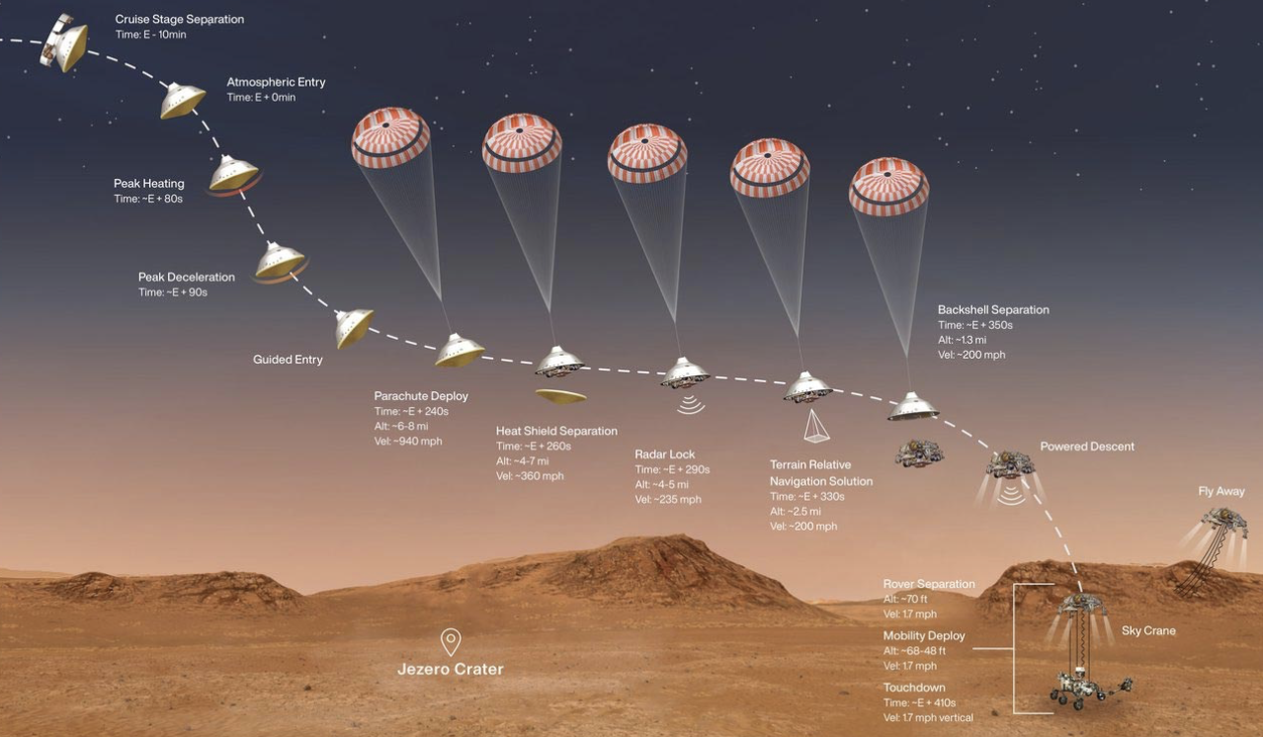

**Figure 4-2.** Sequence of key Mars EDL events.

(20 m) above the surface. The subsystem is lowered through a set of cables about 21 ft (6.4 m) long and the lander touches down, with the cables detaching and the descent vehicle flying off and crashing a safe distance away from the lander. After this, the lander, with the rover and MAV inside, will “unfold” its petals and the rover will roll off to continue its mission. The lander, with the MAV still attached to the inside of one petal, will fold back up in order to protect the MAV from the Martian environment. The base of the lander will have dimensions for its longer sides being 10ft (3m), with its shorter sides being 3.3 ft (1m) in length and the hexagonal cut in the middle being located 2 ft (0.61m) from the top and the bottom edges. The hexagonal cut has a side length of 2 ft (0.61m).

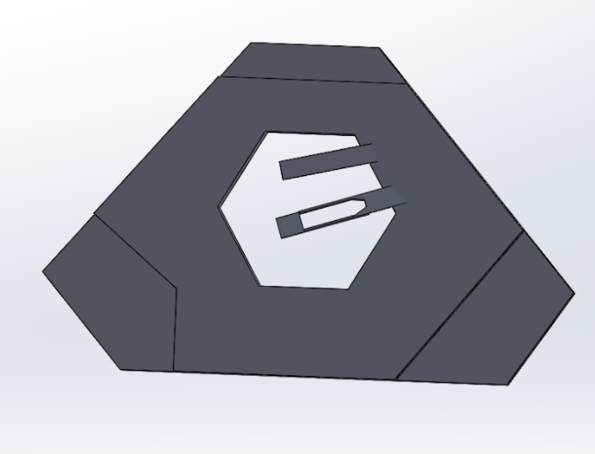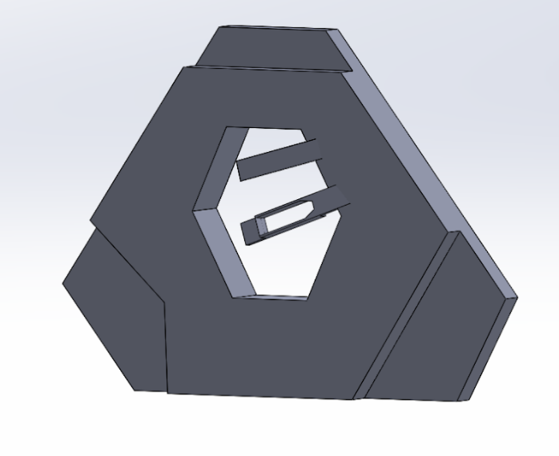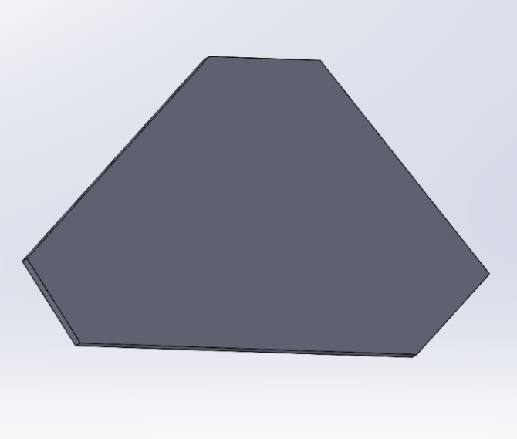

**Figure 4-3.** Lander CAD Renderings.

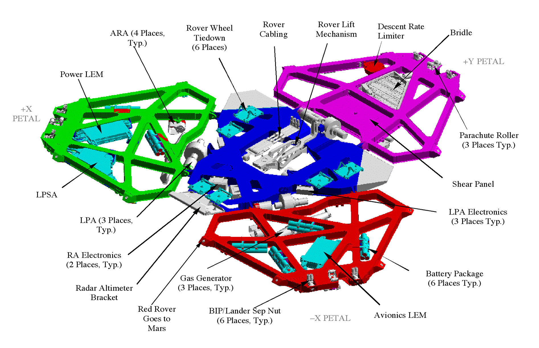

**Figure 4-4.** Mars Lander Concept.

# 5. Rover

**Table 5.** Rover System Level Requirements.

|  |  |  |  |
| --- | --- | --- | --- |
| **#** | **Requirement** | **Rationale** | **Traceability** |
| **System Level Requirements** | | | |
| 1.01 | The rover shall identify the depth of ice below the Martian surface. | The rover should be able to determine the depth of ice below the surface in order to identify suitable drilling locations. | MO.1, MO.3, MO.8 |
| 1.02 | The rover shall collect ice core samples of at least 25 mm in diameter. | The rover should be able to retrieve samples of this size constraint. | MO.3 |
| 1.03 | The rover shall collect ice core samples of at least 100 mm in length. | The rover should be able to retrieve samples of this size constraint. | MO.3 |
| 1.04 | The rover shall store ice core samples in a frozen state at a temperature of 140±2°K throughout the duration of Martian surface operations. | The rover should be able to preserve ice cores in a frozen state during operations on the Martian surface. | MO.1 |
| 1.05 | The rover's robotic arm shall support a maximum payload mass of 20 kg. | The robotic arm should be able to support the mass of all instruments and payloads. | MO.3 |
| 1.06 | The rover's drill system shall support operational rotational speeds of 100 rpm to 300 rpm. | The drill should operate at rotational speeds that facilitate movement of material up the auger without melting ice core samples. | MO.3 |
| 1.07 | The rover shall transfer collected ice core samples to the Mars Ascent Vehicle (MAV) for launch from the Martian surface to Mars orbit. | The rover should be able to move its samples to the MAV for transport to Mars orbit and eventually back to Earth. | MO.1, MO.10 |

## 5.1 System Overview:

The rover has three primary objectives on the surface of Mars: to collect ice core samples of the anticipated dimensions, to safely store these ice cores, and to install them in the MAV in an efficient and safe manner. The rover is further required to maintain the purity of the samples, not contaminating them with Earth-borne microbes or other particles. In order to aid in sample collection, the rover is equipped with an arm, a drill, and a sample storage container. The rover additionally contains a computer system for independent GNC, a nuclear-based power component to ensure that it will have enough life to complete its mission, a communications system with capabilities to ensure direct communication with the orbiter and the DSN, a cooling system with the ability to maintain the solid phase of the ice cores while in storage, and a wheel and suspension system that minimizes rover skidding and prolongs wheel integrity. The rover also contains the instruments necessary to complete its objectives: temperature probes, material composition probes, and cameras that permit its success and integrity to be evaluated at any time throughout the mission.

**5.1.2 Rover System Concept of Operations: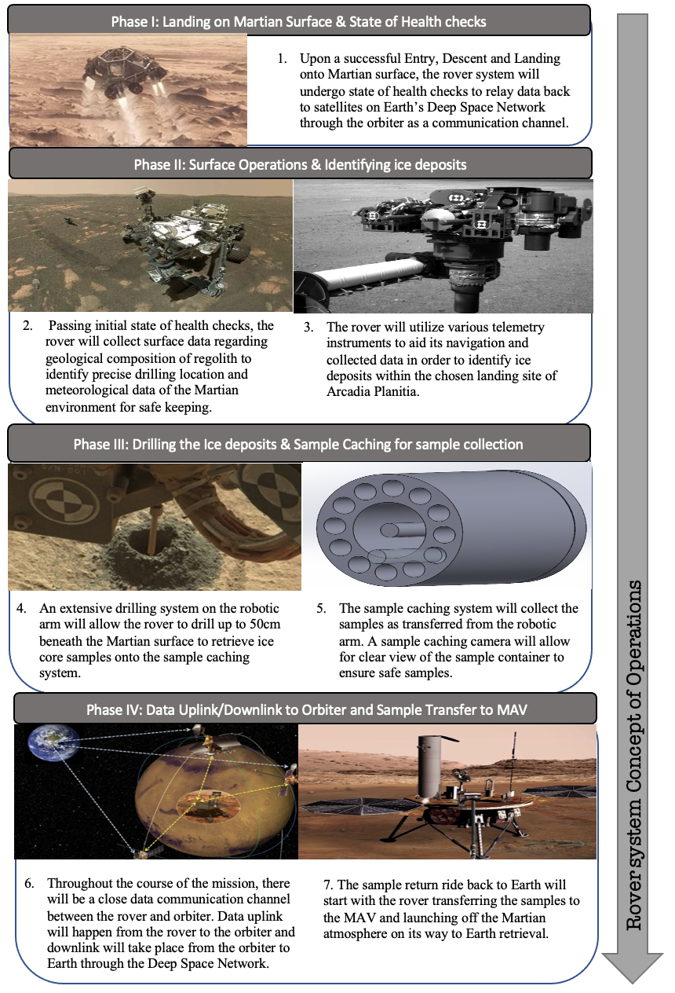5.1.3 Rover System Risk Assessment and Matrix**

**Table 5-1-3.** Risks associated with rover operations on the Martian surface along with proposed mitigations.

|  |  |  |  |  |  |
| --- | --- | --- | --- | --- | --- |
| **Risk** | **Description** | **Effect** | **Mitigation** | **Likelihood**  **(initial and final)** | **Severity**  **(initial and final)** |
| R1 | Drilling bit getting stuck on rough terrain | Damage to the robotic arm, and possibility of sample retrieval failure. | Carry various backup drill bits and ensure enough torque from the motor and high enough speeds to prevent getting stuck. | 4.i, 3.f | 4.i, 3.f |
| R2 | Rover wheels facing terrain navigation challenges | Failure to design proper wheels for any occasion can result in rover inactivity. | Account for the best type of wheel material and suspension system. | 4.i, 2.f | 3.i, 3.f |
| R3 | Rover facing health challenges due to temperatures and radiation | Failure to monitor rover conditions could be detrimental. | Perform constant state of health checks and have freon cooling systems on critical components sensitive to temperature. | 3.i, 2.f | 4.i, 1.f |
| R4 | Martian dust interfering with the rover and components | Dust could cause damage to rover components and contamination back to Earth. | Design the components and systems to be able to prevent contamination. | 3.i 2.f | 2.i 2.f |
| R5 | Complications with extracting ice core samples through faulty sample tube performance or from drilling malfunctions. | Failure to extract the minimum number of samples would result in a mission failure. | Carefully design and test the drilling system to account for all possible challenges and place cameras to monitor sample caching systems. | 4.i, 2.f | 5.i , 4.f |
| R6 | Failure for rover to communicate with the orbiter | Orbiter will be unable to send or receive data information back to Earth. | Establish strong communication between the rover and orbiter system through UHF antennas. | 2.i, 2.f | 5.i , 4.f |
| R7 | System facing complications upon EDL sequence | Rover not being able to safely land. | Perform lots of Monte Carlo rns Ensure that GNC algorithms are robust for all conditions. | 3.i, 2.f | 5.i, 4.f |
| R8 | System not being able to identify ice deposits. | Not being in the correct landing site or precise drilling  location would cause problems to the mission | Landing site was carefully selected through images and  data from the MRO. Instruments on the rover will help identify precise ice depth and location. | 3.i, 1.f | 5.i, 2.f |
| R9 | System not being able to maintain ice cores in their solid phase | Compromise of cooling system could result in melting of ice cores and failure of mission | Cooling system was placed in a highly shielded part of the rover with structural support. | 2.i, 1.f | 4.i, 4.f |
| R10 | System collecting ice samples that are smaller than the anticipated dimensions | Ice samples smaller than the specified dimensions would cause a lack of material to analyze and fail to meet requirements of the client | Rover drill was designed to only drill an ice core of the specified dimensions; checks in mass and dimensions are performed several times before storage. | 2.i, 2.f | 3.i, 2.f |
| R11 | System collecting ice samples that are larger than the anticipated dimensions | Ice samples larger than the specified dimensions would add unanticipated mass to the system, and in extreme cases, not fit inside the sample storage | Rover drill was designed to only drill an ice core of the specified dimensions; checks in mass and dimensions are performed several times before storage. | 2.i, 2.f | 4.i, 2.f |
| R12 | Rover power systems do not supply adequate power to the computers and/or other systems of the rover | Insufficient power may compromise certain mission objectives. | Rover power system relies on reliable, fission energy, using components that have been employed numerous times in other rover missions. | 2.i, 1.f | 5.i, 5.f |
| R13 | Rover does not collect appropriate meteorological and geological Martian surface data from telemetry. | Unable to perform critical tasks to oversee Martian conditions and precise drilling locations. | Rover will be equipped with data-collecting instruments similar to previous successful rover missions for best results. | 2.i, 1.f | 4.i, 3.f |

**Table 5-1-3-1.** Rover Risk Matrix (#.i is the initial risk, #.f is the final risk after mitigation).

|  |  |  |  |  |  |  |
| --- | --- | --- | --- | --- | --- | --- |
| **Risk Matrix** | | | | | | |
|  | **Severity** | | | | | |
|  |  | 1 | 2 | 3 | 4 | 5 |
| **Likelihood** | 1 (0-10%) |  |  | R13.f | R9.f | R12.f |
| 2 (11-20%) | R8.f | R4.f, R3.f, R10.f, R11.f | R10.i | R7.f, R6.f, R5.f, R9.i, R11.i, R13.i | R6.i, R12.i |
| 3 (21-40%) |  | R2.f, R4.i | R1.f | R3.i | R7.i, R8.i |
| 4 (40-90%) |  |  | R2.i | R1.i | R5.i |
| 5(90-100%) |  |  |  |  |  |

## 5.2 Command and Data Handling (CDH):

**Table 5-2.** CDH Subsystem Level Requirements.

|  |  |  |
| --- | --- | --- |
| **#** | **Requirement** | **Rationale** |
| **CDH Subsystem Level Requirements** | | |
| 5.2.1 | The CDH subsystem shall control the operation of all other rover subsystems. | The CDH subsystem should be the center for controlling all onboard operations for the rover. |
| 5.2.2 | The CDH subsystem shall have enough processing power to handle all rover data collection. | The subsystem needs to withstand the high amounts of data being processed within the data collection. |
| 5.2.3 | The rover CDH subsystem shall be capable of communicating to the orbiter’s CDH subsystem to relay data. | The rover must be able to relay data to the orbiter that transmits the data back to Earth. |

The heart of the mission comes down to the central processing unit (CPU) in the rover C&DH subsystem that executes the software for vehicle and mission management. In order to ensure the best processor, a trade study was conducted comparing the BAE Systems’ RAD750 as previously used on the Perseverance and Curiosity rovers and RAD6000 as was previously used on the Spirit and Opportunity Rovers, and both among various other NASA missions.

**Table 5-2-1.** CPU Trade Study.

|  |  |  |  |  |  |  |
| --- | --- | --- | --- | --- | --- | --- |
| **CPU** | **RAM** | **Flash Memory** | **Speed** | **Power** | **Cost** | **EEPROM** |
| BAE RAD750 | 256 MB | 2 GB | 110 - 200 MHz | 5 Watts | $200,000 | 256 KB |
| BAE RAD6000 | 128 MB | 128 MB | 2.5- 33 MHz | 5 Watts | $200,000 | 3 MB |

From the trade study, it’s clear to see the RAD750 will be the most efficient processor for the mission as the RAD6000 is 10 times slower and holds 8 times less memory than its competition. The RAD750 flight computer will hold architecture for the PowerPC750. The processor has the processing power available for reliable transmission to withstand immense amounts of radiation during the mission within interplanetary space and the Martian surface. Additionally, it can withstand temperatures between -55 $℃$ and 70 $℃$ The hardened processor against radiation can prevent physical damage to the integrated circuits. In order to mitigate the risk of failure of the primary processor, a backup processor will be in place. The CPU will use Wind River’s VxWorks as the real-time operating system (RTOS) to execute the rover’s mission-critical tasks while being able to run multiple tasks with shared memory allocation. The Vehicle and Mission Management Software on the rover is active during all phases of the mission and includes the fault protection system in every subsystem that autonomously checks and addresses faults or malfunctions. The rover will also contain a radiation tolerant NAND Flash memory Solid-State Data Recorder (SSDR) as the primary storage for science instrument data. The SSDR, developed by Airbus Defense and Space offers up to 4 Terabytes of storage capacity with a mass less than 14kg. The SSDRs have been used on previous NASA missions including NISAR, and are currently being used in 34 successfully launched satellites. The SSDR based on Flash technology can have storage capacities from 1Tbit to 20Tbit, up to 20Gbps input data rate and 4Gbps downlink data rate, a maximum of 5% degradation, additionally the lifetime of the component can range up to 15 years for usage, which exceeds the need for the sample return mission.

**Table 5-2-2.** Airbus High Capacity NAND Flash SSDR Data.

|  |  |
| --- | --- |
| **Capabilities** | Values |
| **Capacity** | 4 Tbit |
| **Data Rate** | 1 Gbps |
| **Mass** | 14kg |
| **Power** | 35W |
| **Thermal Environments** | -25℃ to +60℃ (operating)  -40℃ to +75℃ (non-operating) |
| **Reliability** | 0.99 over 7 years in orbit |

## 

## 5.3 Electric Power System (EPS)

**Table 5-3.** Rover EPS Requirements.

|  |  |  |
| --- | --- | --- |
| **#** | **Requirement** | **Rationale** |
| **EPS Subsystem Level Requirements** | | |
| 5.3.1 | The EPS shall provide enough power to ensure the reliable operation of all mechanical systems on the rover. | This mission relies on many mechanical systems to be successful; all of these systems require power. If power cannot be provided, the mission is jeopardized because the rover cannot move. |
| 5.3.2 | The EPS shall provide enough power to reliably operate sample caching systems during sample retrieval. | The goal of the mission is to drill and store ice samples. Without power to operate the sample collection systems, the mission fails. |
| 5.3.3 | The EPS shall provide power to communication systems to ensure information can be sent to and received from the rover. | If we cannot communicate with the rover and send it instructions, the mission cannot be completed. |

This mission requires a power source that is not only reliable, but will provide enough power to operate all mission critical rover systems effectively. Historically, two power sources have been used on mars rovers, solar arrays or RTGs. Both solutions have their positive and negative aspects and have been proven reliable after decades of development and usage.

Team Perseus chose an RTG to power our rover and its various systems. An RTG uses the decay of Plutonium-238 to generate heat. This heat is then converted to electricity using thermocouples. We specifically chose the MMRTG, which was used on the two most recent Mars rovers *Curiosity* and *Perseverance.* It alone generates around ~120 watts of power at 30 volts. The unit weighs 45 kg (94 lbs.), 4.8 of which is the Plutonium dioxide fuel for the 8 General Purpose Heat Source (GPHS) modules.

**Figure 5-3-1.** Models of a MMRTG.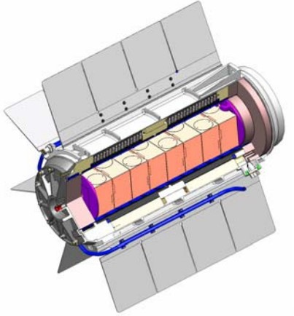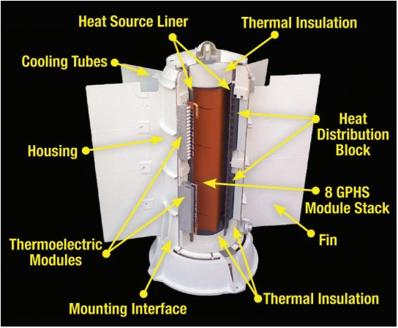

The RTG alone will not be able to power the drill and other systems under heavy load. This is why we will also be using Lithium-ion batteries in conjunction with our RTG. The MMRTG will charge the batteries prior to any energy intensive operations such as drilling. This combination will give us enough power to run the drill and will allow the rover to operate under heavy load. Lithium-ion batteries are a proven technology that allows for reliable charging and discharging for the duration of our mission. Two lithium ion batteries with similar specifications to the EaglePicher batteries used on the perseverance rover will provide the additional power we need for our mission. Each is a 43-amp-hour, 28 volt battery consisting of eight individual cells. Combined they weigh 26.8 kilograms. These batteries are designed to last up to 10 years, which means that they will be more than sufficient for the relatively short duration of our mission. The batteries will allow for a power demand of over 600 watts which is enough to sustain the rover, see Table 5-3-1.

**Table 5-3-1.** Rover Power Consumption.

|  |  |
| --- | --- |
| **System** | **Approximate consumption during standard operation** |
| Drilling/sample storage | ~100 watts |
| Movement/Automation | ~100 watts |
| Loss to decay | 0.787% per year |
| Communication | X Band: < 100 watts  Ka Band: < 35 watts  UHF: 5-7 watts |

The primary drawback of the MMRTG is cost. The plutonium dioxide required to power the RTG is very expensive to produce. The actual RTG is not very expensive to produce however, the 4.8 kilograms of Plutonium needed to power the rover costs an estimated $77 Million in 2017. An MMRTG has a lifespan of 14 years however, over its mission life its power output decays at a rate of about .8% per year. Due to the relatively short duration of our mission, this was deemed not to be a concern.

There are other forms of RTGs that have been developed by NASA and its partners. One of these is the Advanced Stirling Radioisotope Generator (ASRG). The ASRG uses a Stirling cycle to more efficiently convert the energy from Plutonium into usable energy, as a result, the ASRG uses much less plutonium, only about a quarter of what is required by the MMRTG. It does all of this while being relatively compact. This sounds like a very attractive solution however, due to the lack of usage compared to an MMRTG, we have not pursued it due to the inherent risk of using new and unproven technology.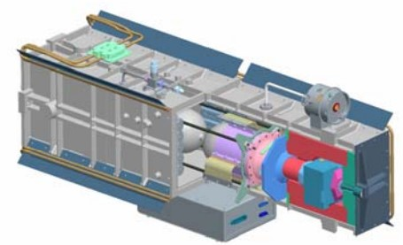

**Figure 5-3-2.** Model of an ASRG from NASA.

Solar panels were rejected after the conclusion that they are too heavy and bulky for our rover. Another important consideration is that solar flux drops according to the inverse square law when moving further away from the sun. On the Martian surface, the maximum solar irradiance is around 590 W/m^2 compared to 1000 W/m^2 on Earth. See Figure 5-3-3. As a result, using solar cells becomes much less efficient. In the relatively dusty arcadia Planitia, using solar arrays adds an extra level of risk to our mission. If the rover’s solar arrays were to become obstructed, the drill, communications, and other mission critical systems will go without power. Having a more reliable source of power in the form of an MMRTG was deemed to be the best choice for this mission.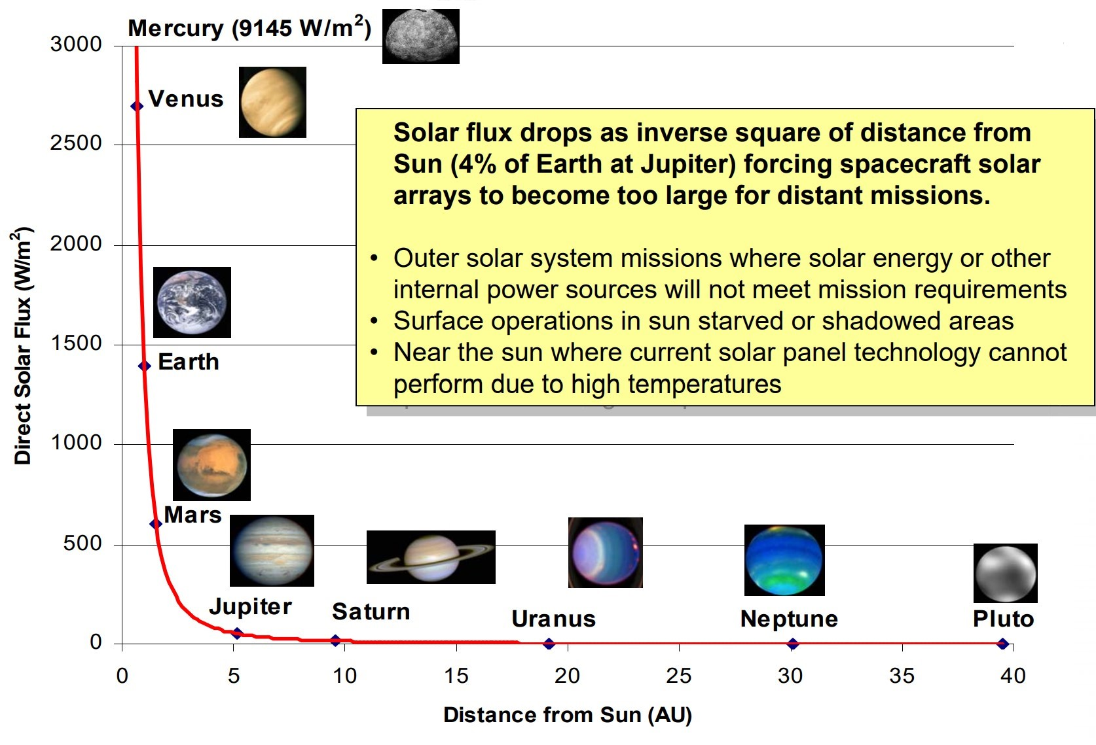

**Figure 5-3-3.** Graph Showing Solar Flux from NASA.

## 5.4 Communication System (COMMS)

**Table 5-4.** Rover COMMS Requirements.

|  |  |  |
| --- | --- | --- |
| **#** | **Requirement** | **Rationale** |
| **COMMS Subsystem Level Requirements** | | |
| 5.4.1 | The rover’s communication system shall transmit data to the orbiter. | The orbiter will serve as a midpoint between most communication between the rover and Earth. |
| 5.4.2 | The rover communication system shall communicate with the Deep Space Network on Earth. | The rover must be able to communicate to earth in cases where the orbiter is not present to transmit data. |
| 5.4.3 | The rover’s communication system shall include at least one low gain antenna. | A low gain antenna will be used for low rate direct from earth commands. |
| 5.4.4 | The rover’s communication system shall contain a high gain antenna. | A high gain antenna will be used for more than half of all communications transferred for both direct-to-Earth and direct-from-Earth communication. |
| 5.4.5 | The rover shall have a link margin no greater than 6dB | The ideal link margin is between 3-6dB to account for unknown variables. |
| 5.4.6 | The rover shall be able to transfer at least 100 megabits of data to the orbiter during a martian day. | The rover must be able to transmit data rates from the orbiter from 100 to 250 megabits per period for a successful mission. |

The period for the mission is defined as one Martian day, referred to as sol, that is equivalent to approximately 1 Earth day for calculation. In order to transmit large amounts of data from the rover back to Earth, it’s imperative to have a strong foundation of the communications of the rover. The rover system will utilize X band radio wavelength to communicate rather than the S band that is used in older spacecraft with larger antennas that require more power. Three main antennas will be utilized by the rover: an ultra-high frequency (UHF) antenna for communication between the rover relaying information to the orbiter, an X-band High Gain Antenna and an X-band Low Gain Antenna for communications between the rover and via the DSN. The UHF antenna will include an L3Harris’ UHF transceiver of about 400 megahertz for communications with the orbiter. The orbiter is utilized as a middle ground between transmitting data between maintaining communication with the rover at least 12 hours a day the rover and the Deep Space Network satellite dishes on Earth since the orbiters have powerful antennas and can achieve high data rates with certain orbiters and transmit around 100 to 250 megabits of data per day of which the same 250 megabits would take a transmit to Earth of about 20 hours from the rovers’ weaker antennas. When the orbiter is passing overhead from the rover, around 8.5 MB of data can be transmitted. Additionally, the rover is only able to transmit direct-to-Earth during specific hours of the day due to power limitations and scheduling on the Deep Space Network whereas orbiters are readily available for transmitting data from their bigger antennas.

**Table 5-4-1.** Rover Data Budget per period.

|  |  |  |
| --- | --- | --- |
| **Subsystem** | **Component** | **Data Return** |
| PAY | Navigation Cameras (2) | 70 MB |
| PAY | Hazard Cameras (4) | 20 MB |
| PAY | Sample Caching Camera | TBD |
| PAY | Master Camera | 148 MB |
| PAY | Chemical Composition camera | 15.5 MB |
| PAY | Instrument for Rock Chemical Composition | 16 MB |
| PAY | Instrument for Detection of minerals | 79.7 MB |
| PAY | Ground radar instrument | 0.01 MB |
| PAY | Weather Measurer | 11 MB |
|  | Total Data Return per day | $⩰$ 400MB |

**5.4.1 Deep Space Network:**

The DSN consists of 3 satellite dishes placed approximately 120 degrees apart around the world in strategic locations that permit constant communications with and tracking of interplanetary locations and distant spacecraft regardless of Earth’s rotation. The DSN’s antennas range in size from 34m to 70m to receive large quantities of data from different spacecraft. Special scheduling alots time for the satellites to focus on specific spacecraft signals throughout the day. The DSN has disk antennas consisting of one 70 metre diameter parabolic dish antenna, one 34 metre diameter HEF parabolic dish antenna, and one 34 metre diameter BWG parabolic dish antenna. The rover will only use X band rather than K or Ka band frequencies since the DSN only allows for S band and X band communication.

**Table 5-4-1-1.** Data budget table for the DSN antennas.

|  |  |  |  |  |  |  |  |
| --- | --- | --- | --- | --- | --- | --- | --- |
| **Antena:** | **70-m** | | **34-m HEF** | | **34-m BWG** | | |
| **Band:** | **S** | **X** | **S** | **X** | **S** | **X** | **Ka** |
| Tx Freq. Range [MHz] | 2090-2118 | 7145-7190 | 2025-2110 | 7145-7190 | 2025-2120 | 7145-7235 | 34315-34415 |
| Tx Gain [dBi] | 62.95 | 73.23 | 55.40 | 67.05 | 56.25 | 67.09 | 79.52 |
| Tx Beamwidth [degrees] | 0.128 | 0.038 | 0.258 | 0.077 | 0.263 | 0.077 | 0.016 |
| Tx Power [dBm] | 73 | 73 | 54 | 73 | 73 | 73 | 59 |
| Rx Freq. Range [MHz] | 2200-2300 | 8200-8600 | 2200-2300 | 8200-8600 | 2200-2300 | 8400-8500 | 31800-32300 |
| Rx Gain [dBi] | 63.59 | 74.55 | 56.07 | 68.41 | 56.84 | 68.24 | 79.00 |
| Rx Beamwidth [degrees] | 0.118 | 0.032 | 0.242 | 0.066 | 0.242 | 0.066 | 0.017 |

**5.4.2 X-Band High-Gain and Low-Gain Antenna:**

The rover’s X-band High Gain Antenna transmits high-rate data to Earth and is flexible and steerable to point its radio beam in any direction without needing the rover to change its position. The HGA is about 28cm in diameter. Half of the communications are transferred through the High-Gain antenna as they are used for direct-to Earth communications (DTE) and direct-from-Earth (commanding). The X-band Low-Gain Antenna is used for omni-directional transmission and receipt of low rate data from the DSN antennas on Earth. The LGA are used for low rate DFE commands but not any DTE data. Both antennas are capable of receiving the 7.2GHz uplink signal and transmitting an 8.4 GHz downlink signal. The low gain antenna transmits signals at a lower rate to the DSN antennas and communicates with the orbiter passing overhead and an orbiter already present in the Mars communication relay like the MRO if needed..

### 5.4.3 Ultra-High Frequency Antennas:

UHF Antennas are utilized for communications with Earth through data transmittance between the rover to overhead orbiters as it takes about 5 to 20 minutes for a signal to travel the distance between Mars to Earth from an orbiter depending on their positions. Team Perseus will be establishing this communication through our own orbiter. As mentioned, this UHF band will be provided by L3Harris’ Rover 6S transceiver , the next generation of the Rover 6 transceiver. UHF transceiver of about 400megahertz with up to two megabits per second on the rover-orbiter relay link. L3 Harris transceivers take only 1 millisecond to communicate from the rover to the orbiter up to 200 miles overhead. The transceiver allos for 100 times more data than previous communication link Mars missions.

**Table 5-4-3.** Rover Transceiver Stats.

|  |  |  |  |  |  |
| --- | --- | --- | --- | --- | --- |
| Component | UHF Capabilities | Size | Weight | Power | Operating Temperature |
| Rover 6S Transceiver  (L3 Harris) | 225 to 512 MHz | 6.75” x 4.30” x 17.61” | <10 lb (<4 kg) | 10 to 32 VDC | -40 $℃$ to 60 $℃$ |

### 

### 5.4.4 System Data Rates

**Table 5-4-4.** Data rates calculated for the 3 rover antennas.

|  |  |  |  |  |
| --- | --- | --- | --- | --- |
| **Variable** | **Units** | **Low Gain Antenna (LGA)** | **High Gain Antenna (HGA)** | **UHF Antenna** |
| Transmit Gain | dBi | 5.0 | 25.5 | 6.0 |
| Receive Gain | dBi | 5.0 | 20.2 | 5.0 |
| Frequency | MHz | 7,000 - 8,000 | 7,000-8,000 | 401.5 |
| Power | Watts | 15.0 | 15.0 | 6 (receiving), 43 (receiving/transmitting) |
| Downlink data rate | b/s | 15 | 160 - 800 | 250 - 256,000 |
| Downlink signal | GHz | 8.4 | 8.4 | - |
| Uplink data rate | kb/s | 0.875 | 1.85 | 250 - 32,000 |
| Uplink signal | Ghz | 7.2 | 7.2 |  |
| Mass | kg | 1.4 | 8.0 | 1.90 |

The rover communication subsystems consisted of transmitters, transponders, transceivers, and 3 antennas as mentioned above. The following table demonstrating the total mass and power shows the components adding up to a total mass of 22.5 kg and a total power of 108.1 watts.

**Table 5-4-5.** COMMS Mass and Power Budget.

|  |  |  |  |
| --- | --- | --- | --- |
| **Component** | **Quantity** | **Mass (kg)** | **Power (W)** |
| Transmitters | 2 | 5 | 10 |
| Transponders | 2 | 3.2 | 12.5 |
| Transceivers | 2 | 3.0 | 12.6 |
| Antennas | 3 | 11.3 | 73 |
|  | Total | 22.5 | 108.1 |

## 5.5 Guidance, Navigation & Control (GNC)

**Table 5-5-1.** GNC for Rover Requirements.

|  |  |  |
| --- | --- | --- |
| **#** | **Requirement** | **Rationale** |
| **GNC Subsystem Level Requirements** | | |
| 5.5.1 | The rover shall be able to determine its attitude in the Solar system. | The rover’s attitude is crucial to ensuring proper communication for data transfer between the rover and orbiter. |
| 5.5.2 | The rover shall be able to determine its orientation in the Solar system. | The orbiter must be able to detect the rover’s location in order to perform data transfers. |
| 5.5.3 | The rover shall be able to develop disparity maps for perception. | Disparity maps allow the rover to see the area surrounding it and aid in path planning. |
| 5.5.4 | The rover shall capture stereo images with an image resolution of at least 512 x 512 pixels for the disparity maps. | The rover shall capture stereo images with a resolution that minimizes processing time and maximizes image quality. |
| 5.5.5 | The rover shall capture stereo images with an image resolution of maximum 1024 x 1024 pixels for the disparity maps. | The rover shall capture stereo images with a resolution that minimizes processing time and maximizes image quality. |
| 5.5.6 | The rover shall be able to develop a traverse monitoring map to be used by the Traverse Monitoring module. | The traverse monitoring map is instrumental in communicating what areas the rover is permitted to travel. |
| 5.5.7 | The rover shall include a navigation architecture that accounts for path planning in easy to moderately difficult terrains. | The navigation system will be prepared to guide the rover through any type of terrain to avoid any type of obstacles presented in its path. |
| 5.5.8 | The rover shall have a Path Planning module that determines the exact path the rover will take. | The rover is an autonomous system that is reliant on algorithms to determine the best route which is the role of Path Planning. |
| 5.5.9 | The rover shall be able to develop an updated map and terrain model at each stop of its travel. | Updated terrain models allow the rover to adjust for any new changes to the surrounding area influencing its path of travel |
| 5.5.10 | The rover shall be programmed autonomously to avoid obstacles presented in its path. | The rover will utilize NavCams, HazCams, and Localisation cameras to oversee its path and perform path trajectory corrections to avoid the obstacles. |
| 5.5.11 | The rover shall have path sequences of smooth and point turn maneuvers. | This combination allows for the rover to navigate a variety of terrains and around obstacles to arrive at its end point. |

## 

The objective of the GNC architecture is to maximize the ability of the rover to navigate and translate autonomously. Our GNC system will fully leverage the proven features of previous architectures to minimize risk, while infusing new ideas and concepts to enhance functionality. To achieve the desired mobility, GNC includes a set of subsystems comprising hardware components and software algorithms. These subsystems are described below.

**5.5.1 Perception**

The perception system is responsible for creating disparity maps from a pair of stereo images. These stereo images are developed by an auto-exposure algorithm. Disparity maps are ideal for perception because they convert 2D pixel locations to 3D points in space, which is beneficial for navigation. This module uses multi-resolution cameras to allow for the maximum of mapped terrain in addition to minimizing process time. It is important that the perception system must not only create the disparity map, but also update these maps fast enough as the rover travels across the Martian surface. Continuing to touch on the necessity of speed, research has found that resolution can play a huge role. For example, a jump from 512 by 512 to 1024 by 1024 is detrimental as it increases the process time to a value that is just not acceptable for the reason previously mentioned. One of the risks that needs to be addressed is how to mitigate the image noise. The solution is a Laplacian of Gaussian pre-filter which minimizes the noise and matching errors that could arise; yet another risk mitigation. To further reduce risk, gradient images are heavily processed to develop the clearest picture necessary for path planning.

In our quest for ideal locations to mine ice cores, our camera repository will also include cameras for sensing these spots. These cameras will be found on the rover arm as previously described. This additional information is different from past missions but will be instrumental in acquiring the best samples.

**Figure 5-5-1.** Disparity Maps.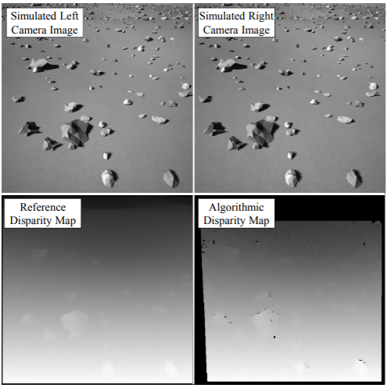

**5.5.2 Navigation**

To support the next element of the GNC architecture (the Path Planning module and Traverse Monitoring module), the Navigation module is responsible for creating an updated map at each navigation stop. The disparity maps, produced by the perceptions system, are transformed into a terrain model. Analysis of this model takes into account several attributes including step height, rover clearance and rover tilt angle. The final result of the models are 2D maps on a Cartesian grid, a terrain feature map. The outputs of this module are a finalized region navigation map, and escape boundary. The escape boundaries can also be thought of as reasonable path sequence end points. Furthermore, the traverse monitoring map is developed to specifically be used for the Traverse Monitoring module. This map details the areas that the rover can and cannot enter leading to the creation of several potential paths. The Navigation module has processes built in to account for disturbances and is constantly updating.

These images above ground will allow the rover to navigate through any obstacles that might present themselves. Likewise, our mission must account for stops along the way where the rover’s robotic arm will be utilized to decide if this location is worth mining.

**Figure 5-5-2.** Navigation Processing Overview.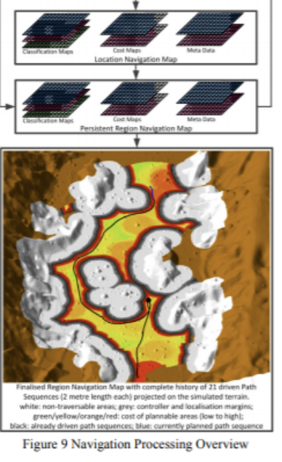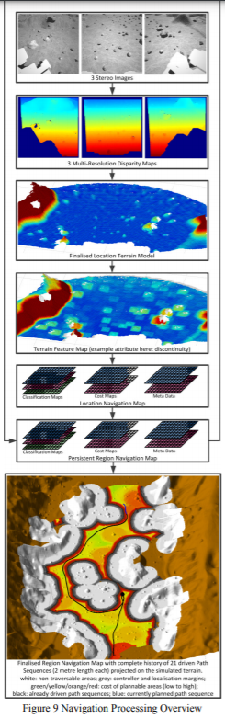

**5.5.3 Path Planning**

Continuing with the theme, the Path Planning module is crucial to the modules that follow. This module communicates to the Trajectory Control module the exact path to be driven. To be more specific, each step of the sequence is 2.3 meters and involves a combination of smooth and point turn maneuvers. The escape boundary is used to determine the best route to the escape point and all movements in between. That being said, the module also accounts for unknown and unavoidable situations to find an alternative path under those circumstances. After the route is chosen, the Trajectory Control module can output turns and curves.

Since the module will be constantly updating, as stops are made and ice cores are mined, there will be pauses and then re-routes that are already incorporated into the algorithms of the Path Planning module.

**Figure 5-5-3.** Path Planning Algorithm Illustration.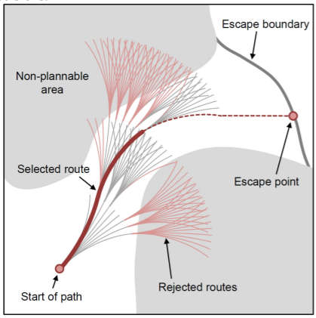

**5.5.4 Localisation**

The goal of the Localisation module determines the rover’s position and attitude on the Martian surface and involves sub-modules. This estimation is made through the local gravity vector and sensing Sun direction. These include Absolute Localisation, Relative Localisation and Wheel Odometry. The purpose of Absolute Localisation is to identify the roll and pitch when the rover has no movement and Relative Localisation performs a similar function while the rover is moving. Similar to other modules, constantly updating eliminates propagation of error. VisLoc, or Visual Localisation, is a special tool used for Relative Localisation that works by tracking frames and understanding how points move. Lastly, Wheel Odometry is the locomotive aspect of Localisation. Utilizing the estimates from VisLoc samples, it creates its own estimations of position increments. Unfortunately, WheelOdo cannot track slipping but the combination of VisLoc with a gyro and the WheelOdo data can be used to determine average slippage as the rover crosses the Martian terrain.

Absolute Localisation will occur at the times of ice core mining. VisLoc and WheelOdo will play crucial roles in ensuring the location chosen is one that the rover will not slip while mining.

**5.5.5 Trajectory Control**

Everything is coordinated in the Trajectory Control module. Using the maps and models created by algorithms in the previous modules, Trajectory Control’s objective is to ensure the rover’s accurate movement along the generated path sequence. This can be achieved through two methods, either through using the Path Planning module or an uploaded ground path sequence. The estimations of rover position and attitude from the Relative Localisation become crucial at this step of the process. From here, the Trajectory Control will determine the commands the rover must follow and translate these commands directly into wheel commands for actual movement.

**5.5.6 GNC Two level Architecture**

Another possible solution to efficiently overseeing the rover’s GNC is to implement a two-step navigation process that includes a lower level efficient navigation that is always active and a full navigation upper level that is enabled when the rover is presented with difficult terrain. This architecture allows for a long range and low supervision exploration for the rover that has previously been tested before as autonomous navigation is a crucial technology for the mission. The architecture works based off of a low-resolution map of the terrain being available from images in order to process the geographic characteristic of the area. In this case, these images can be gathered from previous orbiters such as the MRO as has been done to determine our landing site for the mission. The images will determine terrain classification and obstacles difficulty assessments to decide which navigation level and functionality should be active for a certain distance. This proves more effective than the current navigation approach rovers take where they stop for tens of seconds every few meters to access the terrain traversability to plan for a safe path. This two level navigation architecture allows for both fast and long autonomous traverses in terrains from easy to higher difficulties.

**5.5.6.1 Efficient Navigation Mode**

The first navigation level is the Efficient Navigation level which is used for easy to moderate terrains. The Visual Odometry module that runs over the images of the Localisation Cameras keeps track of the rover’s relative localisation and the trajectory control algorithm to ensure the rover follows a safe path. The Hazard Cameras and Hazard detection algorithm checks for hazards in the rover’s surroundings from analyzing the camera's images. The original location of the rover is found by utilizing camera images and an Inertial Measurement Unit (IMU) for relative localization to provide an estimate of the location. When a hazard is detected near the rover’s trajectory, the system’s replanning is triggered to address and avoid the obstacle. The new path rejoins the original path whenever the obstacle is avoided. All in all, this first level uses autonomous navigation based on hazard detection, local path replanning and trajectory control with visual odometry.

**5.5.6.2 Full Navigation Mode**

The second navigation level is the Full Navigation level which is used for more difficult terrains with more obstacles. This level would prevent the frequent need for replanning when faced with obstacles as the first level does. This level uses the NavCams to map the terrain ahead and a Localization and mapping algorithm that uses the relative localization estimate of the Visual odometry to plan out several meters ahead in order to plan for more optimal paths from the very beginning to avoid hazards smoothly. The local map generated from these algorithms are used to perform pose corrections. This level is running continuously during the rover travel, while the Efficient Navigation level path planning is only activated by the detecting of small hazards.

**5.5.7 Component List**

The following components list is a list consisting of general components used for position determination and attitude determination and control systems (ADCS). These are all components that will be utilized within the rover that have a total of 3.68kg for the mass and 46.605W for the power.

**Table 5-5-7.** GNC Components List.

|  |  |  |  |  |
| --- | --- | --- | --- | --- |
| **Component** | **Manufacturer** | **Model** | **Mass (kg)** | **Power (W)** |
| Reaction Wheels | Berlin Space Technologies | RWA05 | 1.700 | 0.5 |
| Magnetic Torquers | NanoAvionics | MTQ3X | 0.205 | 0.4 |
| Star Trackers | Berlin Space  Technologies | ST400 | 0.280 | 0.65 |
| Sun Sensors | Adcole  Space | MAI Sun Sensor  (CubeSat) | 0.0035 | 0.005 |
| Three-axis Magnetometers | NewSpace Systems | NMRM-Bn25o485 | 0.085 | 0.75 |
| Horizon Sensors | CubeSpace | CubeIR (Infrared sensor) | 0.050 | 0.230 |
| GPS Receivers | Surrey Satellite Technology | SGR-05U | 0.04 | 0.8 |
| Integrated Units | Berlin Space Technologies | iADCS-100 | 0.400 | Unk |
| Atomic Clocks | Microsemi | Miniature Atomic Clock (MAC) | 0.1 | 8 |
| Deep Space Navigation | JPL | IRIS V2. 1 | 1.2 | 35 |
| Gyros | Gladiator  Technologies | LandMark 005 (IMU) | 0.018 | 0.270 |
|  |  | **Total** | **3.68** | **46.605** |

**5.6 Payload and Telemetry**

**Table 5-6.** Rover Payload Requirements.

|  |  |  |
| --- | --- | --- |
| **#** | **Requirement** | **Rationale** |
| **Payload Subsystem Level Requirements** | | |
| 5.6.1 | The payload shall include cameras to assist during autonomous movement around obstacles. | The rover should be able to navigate the Martian surface |
| 5.6.2 | The payload shall include a camera to monitor the secured samples before they are sealed. | The rover should be able to ensure the captured samples are stored safely up until departure back to Earth |
| 5.6.3 | The payload shall include a video camera to record and relay video footage during the mission. | The rover should be able to provide video and camera footage of mission for analysis on Earth |
| 5.6.4 | The payload shall be able to detect minerals within ice cores. | The rover should be able to identify the chemical composition of captured ice cores (minerals) through the CacheCam-like camera and sensor system. |
| 5.6.5 | The payload shall be able to collect information to identify ideal drilling locations through mapping geological features. | The rover should be able to target the area(s) to perform drilling operations |
| 5.6.6 | The payload shall be able to collect atmospheric meteorological data. | The rover should be able to collect weather information and monitor dust |
| 5.6.7 | The payload shall be able to identify the chemical compositional makeup of collected samples. | The rover should be able to identify the chemical composition of captured ice cores |

**Table 5-6-1.** Rover Payloads.

|  |  |  |  |  |  |
| --- | --- | --- | --- | --- | --- |
| **Cameras** | **Role** | **Image Resolution** | **Total Mass** | **Data Return** | **Power** |
| **Engineering Cameras (less than 425 g, 20 megapixels**) | | | | | |
| NavCams (Navigation) | Auton navigation | 0.82 milliradians/pixel | 0.25 kg *2 | 70 megabits  (total) | 2.15 watts * 2 |
| HazCams (Hazard Avoidance) | Auton navigation & obstacle avoidance | 2.1 milliradians/pixel | 0.25 kg *2 | 20 megabits (total) | 2.2 watts * 2 |
| CacheCam | Monitor samples before sealing | 12.5 microns/pixel  20 megapixels | 0.425 kg * 2 | TBD | 2 watts * 12 |
| **Science Cameras** | | | | | |
| MastCam - Z | Video, zoom lens | 150 microns/pixel to 7.4 mm/pixel (depend on distance) | 4 kg | 148 mb/sol, avg | 17.4 watts |
| SuperCam | Chemical composition | unk | Total: 10.6 kg | 15.5 mb/experiment  4.2 mb/day | 17.9 watts |
| PIXL | Measure rock chemical composition | unk | Total: 6.915 kg | 16 mb/experiment  2 mb/day | 25 watts |
| SHERLOC & WATSON | Detection of minerals (biosignatures) | **Autofocus & Context Imager**  10.1 micrometers  **WATSON**  15.9 micrometers  **Laser**  100 micrometers | Turret: 3.11 kg  Body:  1.61 kg | 79.7 Mbits (raw) | Total: 48.8 watts |
| **Total Specifications** | | | | | |
| **Data Volume:** | **unk** | **Mass:** | **40.185 kg** | **Power:** | **141.8 watts** |

The rover payload will consist of a number of engineering and science cameras. Each camera will perform a specific role that aids towards the overall goal for the rover. The engineering cameras will be composed of navigation and hazard avoidance cameras found on the front and back of the rover. Along with this is a camera for monitoring the samples that are put into the storage up until they are sealed for their departure back to Earth. The science cameras all work to analyze the ice cores whether it be their chemical composition or detecting minerals within. These cameras can be found on the turret of the robotic arm. The video camera responsible for taking images and recording videos in color. This device also has a useful zoom function that allows the rover to detect objects farther away.

## 5.7 Sample Caching System

The sample caching system is composed of several sub-parts that are necessary for a successful completion of the mission. Its main goal is to capture and store ice core samples to be transported back to Earth.

**5.7.1 Robotic Arm**

The robotic arm serves several purposes in getting ice cores from the ground into the sample storage container. Firstly, the robotic arm has camera systems on its turret that observe the Martian surface below the rover and measure chemical composition and mineral deposits. The cameras allow the system to determine the ideal location to drill. The drill is also found on the robotic arm turret and will be discussed in further detail later on. Lastly the robotic arm will have to be able to insert the collected ice core samples from the drill into the sample storage container. To achieve these goals, a three-position locking system will be implemented. The first position will be extended , as shown in Figure 5.7.1.1 , where the cameras can map and scan roughly 2 meters in front of the rover. Following is the second position, shown in Figure 5.7.1.2, where the robotic arm will be locked around 1 meter from the front of the rover. This will be the position in which the drill will perform its task of removing ice cores from the Martian ground. Lastly, the robotic arm will swing and lock into its third position where the drill can rotate to inject each sample storage slot with a sample ice core. 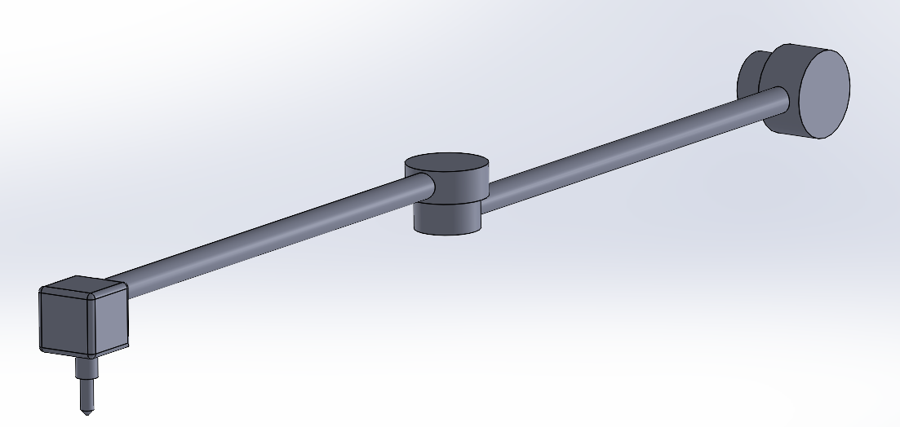

**Figure 5-6-1-1.** Robotic Arm First Position.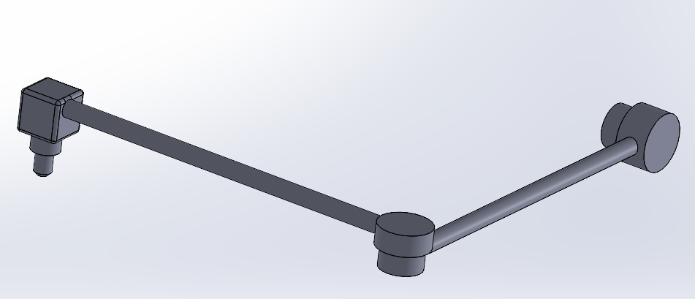

**Figure 5-7-1-2.** Robotic Arm Second Position.

As shown above, the arm can rotate at its elbow and also at the drill. The reasoning behind the locking mechanism is to reduce risk of inaccurate movements that could cause drilling in the wrong location or not being able to insert the sample. When the sample storage system is removed from the rover, it will lock back into its first position to stay out of the way.

**5.7.2 Drilling System**

The drilling system is responsible for collecting ice core samples from the surface of Mars, and as such, is the most important payload of the rover and is critical to mission success. Many challenges are presented by the Martian environment and targeted sample material that have placed constraints on the system and have shaped the design of the drill. Much of the design of the drill system takes inspiration from the ROtary PErcussive Coring Drill (ROPEC) developed by Honeybee Robotics that was designed to collect rock core samples and proposed to serve in the Mars 2020 mission’s sample return architecture. While several changes and additions were made to the system in order to meet the requirements and objectives of our mission, many of the primary mechanisms are reused including most of the actuators and mechanical systems. This serves to reduce the cost of research and development of the drilling system by building off of a platform that has already been developed and extensively tested. 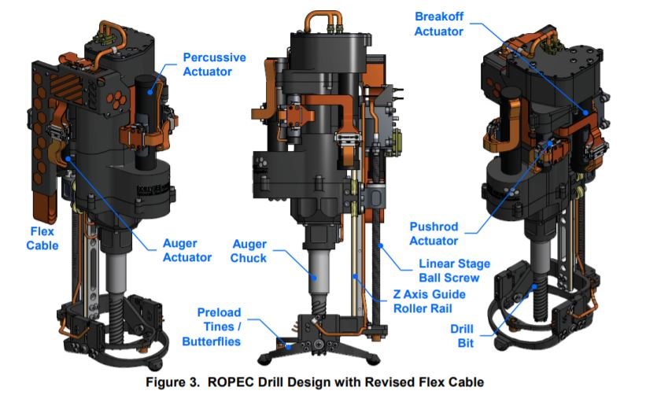

# Figure 5-7-2-1. CAD Renderings of the ROPEC Drill.

The drill is attached to the end of the robotic arm mounted on the front of the rover chassis. In order to meet the payload capacity of the robotic arm of 20 kg, emphasis was placed on reducing mass throughout the drill system. The ROPEC drill was designed with this same emphasis and has a mass of less than 4 kg. With the modifications made in the drill designed for our mission, the mass of the drill system is increased to roughly 7 kg. The auger structure is made of aluminum alloy with a length of 75 cm and an inner diameter of 50 mm. The walls of the auger and the depth of the auger flutes have an additional radius of 2.5 mm each, bringing the total auger diameter to 60 mm. While the length of the entire auger is 75 cm, the hollow inside limits the length of collected cores to 150 mm. So, while the drill may have to be removed from the borehole and its contents unloaded several times to reach the depth of the subsurface ice, this decreases the complexity of the sample collection process by providing for the collection of ice core samples that are precisely 150 mm in length and 50 mm in diameter. Samples of these dimensions have a mass of 0.27002 kg, thus a minimum of 10 samples would need to be collected to meet the required 2.5 kg of returned sample mass. However, more than 10 samples will be collected in order to improve the likelihood of achieving mission success criteria.

**Table 5-7-2-1.** Mass Budget of Drilling System.

|  |  |
| --- | --- |
| **Component** | **Mass (kg)** |
| Drill Mechanisms | 3.75 |
| Auger | 3.295 |
| Drill Bit | 0.1 |
| Sensors | 0.045 |
| **Total** | **7.19** |

The length of the auger is substantially greater than that of the ROPEC drill and is largely responsible for the mass increase. The longer auger also requires greater power and weight-on-bit (WOB) inputs, but the length was selected in order to accommodate the depth of ice at the chosen landing site. Based on data collected from the Mars Reconnaissance Orbiter and the Mars Odyssey Orbiter, it was determined that the ice depth at our chosen landing site, SROI 1, is roughly 30 cm. Thus, the 75 cm length provides the capability of collecting core samples from ice up to 50 cm beneath the Martian surface which gives more flexibility in the selection of drilling locations and increases the overall probability of mission success.

The drill bit is located at the end of the auger and is responsible for carrying out the drilling action. The drill system utilizes a hybrid bit design which incorporates both diamond impregnated elements with a discrete cutter bit made of cemented tungsten carbide with an outer layer of polycrystalline diamond on the leading edge of the bit. The bit teeth are set at a positive rake angle in order to drill through softer material, such as ice, more effectively. Bits with positive rake angles are typically avoided due to the fact that they can be easily damaged, however, the hybrid bit design uses this to its advantage. When drilling through soft material, the positive rake angle causes the bit to function in a similar manner to a chisel, such that the grinding of the rock material results in wear of the diamond impregnated element of the bit behind the leading edge of polycrystalline diamond. When hard materials are then encountered, the diamond table on the leading ​edge is chipped and the diamond impregnated element is exposed once again and continues​ drilling while maintaining the positive rake angle. This process is shown in Figure 5-7-2-2 below.

# Figure 5-7-2-2. Diagram of Hybrid Drill Bit Design.

Opting for a hybrid drill bit design is advantageous for a few reasons. First, the drill is able to actively adjust to the material being drilled as the element primarily responsible for drilling changes based on the type of material encountered. Additionally, this process gives the drill bit a self-sharpening and self-repairing mechanism as the sharp diamond table leading edge and impregnated elements are continuously reimposed even after wear. This ultimately enables the bit to effectively drill through any formation that it encounters, affording the drill system greater flexibility than using a solely diamond impregnated bit or a solely discrete cutter bit as they are less effective in certain circumstances, especially in softer materials such as ice which plays a critical role in our mission.

Another important consideration in the design of the drilling system is the removal of the drilled cuttings, this will be done in a couple of ways. The auger located on the exterior of the drill pipe transports cuttings from the bottom of the borehole to the surface via its 2.5 mm deep flutes pitched at an angle of 20°. The pitch height, or height between each flute on the auger, is 15 mm in order to prevent auger choking. Additionally, the surface of the auger flutes are coated in NEDOX, a substance that provides corrosion resistance and reduces friction, thus further facilitating movement of cuttings up the auger and serving as another measure to prevent auger choking. Based on the chosen pitch angle, diameter of the auger, and estimated coefficients of friction, the threshold rpm (revolutions per minute) necessary for cuttings to be moved up the auger is 168.1 rpm. So, the drill will operate in the range of 175 rpm to 275 rpm with the upper bound set to limit the heat produced and energy consumption of the drill. The auger acts as the primary method of cuttings removal while drilling through the overburden layers above the ice that primarily consist of rocks and soil. An additional method of cuttings removal, specifically when drilling ice, is through ice sublimation. If the Martian atmospheric pressure is below the triple point of water (~0.61 kPa), then the heat produced by the drilling process sublimates the ice cuttings directly into water vapor. This greatly simplifies the cuttings removal process and would be considered the ideal scenario. However, if the atmospheric pressure is above the triple point of water, then melting of ice and formation of liquid water in the borehole is possible. If this is the case, the auger will continue to serve as the method of cuttings removal during the drilling of ice. However, augers traditionally struggle with wet and sticky materials which often cause the auger to choke, so additional precautions will need to take place in this scenario. Weather sensors mounted on the body of the rover will measure the atmospheric pressure and inform the control of the drill system based on what cuttings removal method is required.

Due to the hazards posed to the drilling system by the formation of liquid water in the borehole, several sensors are included in the design to monitor conditions in the borehole. First, temperature sensors are embedded within the drill bit to measure the temperature of the surrounding ice formation as well as the ice core sample to ensure that melting is not occurring. In addition, an electrical resistivity sensor is embedded in the drill bit to measure the resistance of the drilled formation. The resistance of the formation changes depending on the amount of liquid water present, so an abrupt change in the resistance of the formation would indicate that melting is occurring. If these sensors suggest that the ice in the surrounding formation is nearing melting temperatures then there are a few actions that can be taken to reduce the drill bit temperature and prevent water from forming, these include reducing the rotational speed of the drill, reducing the WOB, and removing the drill from the hole altogether to allow for cooling before drilling resumes.

Once the drill has reached the appropriate depth to collect a core of the specified dimensions, the core-break off mechanism is activated in order to break the core away from the surrounding formation. The drilling system will borrow the mechanism used on the ROPEC drill which uses a system of two nested tubes to cut the core from the formation. The auger and drill bit make up the outer tube while the inner tube is located inside of this structure. The center hole of these tubes is offset from the central axis of the exterior auger/drill bit structure and are aligned such that the tubes are coaxial during normal drilling operations. In order to prevent unwanted core shearing, the nested tubes must maintain this alignment and spin simultaneously until core-break off is desired. Once the proper depth has been achieved, core-break off is initiated by rotating the inner tube while keeping the outer tube static. This causes a shift in the relative central axes of the inner and outer tubes resulting in the shearing of the core from the surrounding formation and capture of the core within the bit.

**Figure 5-7-2-3.** Core Break Off Mechanism on the ROPEC Drill.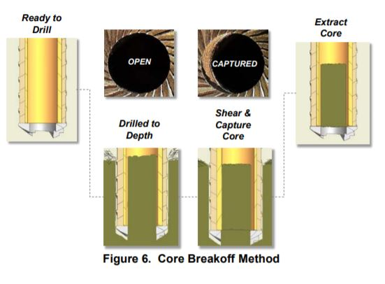

After core-break off has been achieved and the ice core sample is captured within the bit, the drill is removed from the hole and the robotic arm moves the drill to the sample storage system located on the body of the rover. The robotic arm will align the hole of the drill bit with a sample storage container and the drill’s pushrod mechanism will be activated to remove the ice core sample from the drill and transfer it into a sample storage container.

**Table 5-7-2-2.** Power budget of Drilling System.

|  |  |
| --- | --- |
| **Component** | **Power Draw (W)** |
| **Standard Drilling Operation** | |
| Auger Actuator | 150 |
| Temperature Sensor | 0.1 |
| Electrical Resistivity Sensor | 0.1 |
| Telemetry Sensor | 0.25 |
| **Core Break Off** | |
| Breakoff Actuator | 75 |
| Temperature Sensor | 0.1 |
| Electrical Resistivity Sensor | 0.1 |
| Telemetry Sensor | 0.25 |
| **Sample Transfer** | |
| Pushrod Actuator | 25 |
|  |  |
| **Maximum Power Draw:** | **150.45** |

Considering potential risks and developing mitigation methods is also critical in the design of the drill system to ensure a high probability of system success in the harsh conditions of the Martian environment. A primary risk is the drill becoming frozen stuck in the borehole due to refreezing of water produced in the drilling process. Under ideal conditions, the Martian atmospheric pressure would be below the triple point of water and this risk would be minimal. However, if this is not the case, then this is a major risk due to its severity in jeopardizing mission success. The primary methods by which the drilling system mitigates this risk is through the temperature sensors and electrical resistivity sensor embedded in the drill bit to prevent the ice formation from melting. If measurements from these sensors indicate an increase in ice temperature or melting, then the rpm of the drill can be reduced, or the drill can be removed from the hole to allow for cooling. Additionally, backup drill bits will be carried on the rover in the emergency scenario that the drill becomes frozen stuck. Another risk relating to the melting of the ice formation is choking of the auger. The auger is unable to efficiently handle wet and sticky materials, similar to the ones that may be formed during the melting of the ice formation. This risk can be mitigated using many of the same techniques as above in order to prevent the ice formation from melting. In addition, the WOB can be reduced to slow the drill bit’s rate of penetration and reduce the load placed on the auger.

**5.7.3 Sample Storage Container**

The sample storage container is essential for ensuring the collected ice cores are safely managed and transported off the Martian surface and back to Earth. In deciding what exactly the shape and orientation this container should have, many forms were considered. Ultimately, the concept with a simplistic design and that was able to mitigate the most risks was chosen. The figures below depict the cylindrical design for the sample storage container with an ice core. This design is similar to that of a revolver chamber. Only one motor will be needed to rotate the system as each core is collected and the cover depicted on the bottom right will cover the samples already collected. This will minimize the opportunity for dust to enter in and allow the cooling system to work efficiently. The sample storage container can hold up to 12 ice cores even though the minimum needed to meet the weight requirement is 10. This decision was made assuming that some of the collected ice cores may have mineral deposits taking up volume. Without cores, the storage container is roughly 15 kg. As shown in Figure X, there will be a small sensor at the bottom of each cylinder storing slot. This sensor is also referred to as the CacheCam and responsible for two objectives. One will be to

**Figure 5-7-3-1.** Sample Storage Unit with Sensor. 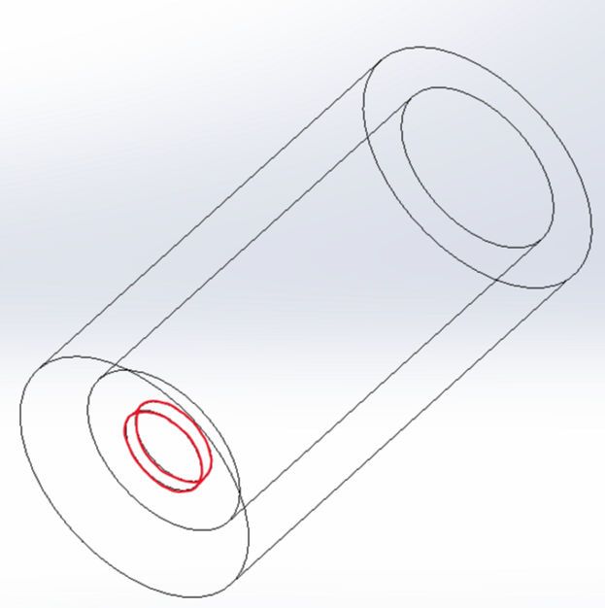

**Figure 5-7-3-2.** Sample Storage Container with Ice Core.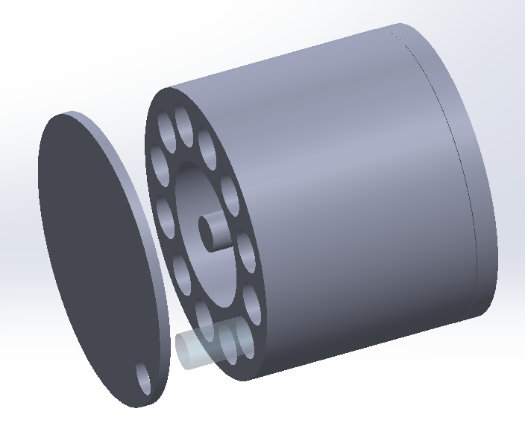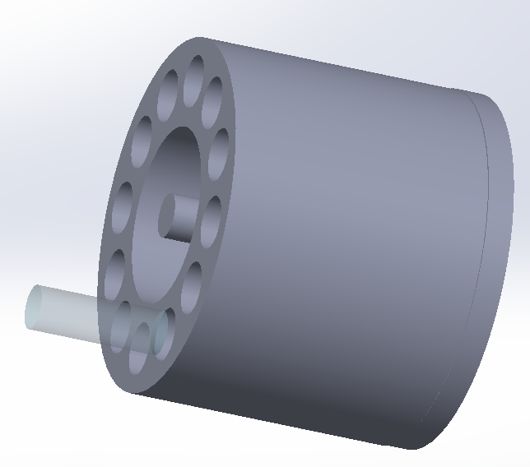

sense when each slot is filled (ensuring all 12 slots get filled) and the second will be to identify the chemical composition of each sample. All wires necessary for the sensors can be kept in the large space around the shaft of the container. The electronics, including the battery, are housed beneath the samples at the base of the container. This storage unit will be at the front bottom of the rover facing outward. The reasoning for this placement is to have the container in the optimal location for the robotic arm to place samples into the storage. The drawing above includes the dimensions of the sample storage container from an orthographic view. 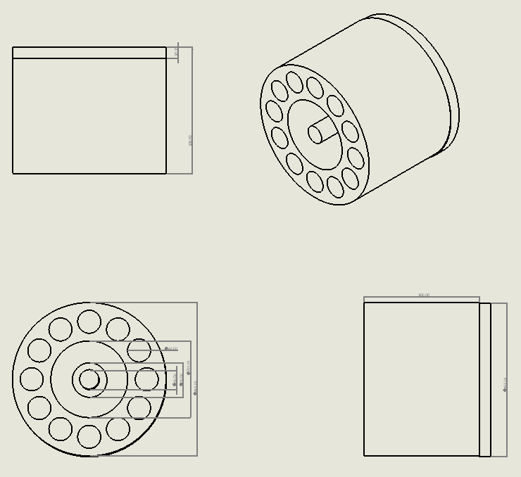

To transport the sample storage container from the rover to the MAV for return to Earth, there will be

**Figure 5-7-3-3.** Sample Storage Orthographic Drawing.

a piston system behind the container within the rover. Once it is time to deploy, the MAV will lower down to the rover and it will activate pushing the container into the MAV. As previously mentioned, the robotic arm will be in its first position and out of the way.

**5.7.4 Sample Cooling System**

The purpose of the sample cooling system is to ensure that the ice cores remain in their solid phase for the duration of the mission. For this, a carbon tetrafluoride-based Freon-14 cooling loop is employed. This cooling system will ensure that the ice cores will maintain a temperature of 140 ± 2 Kelvin. As stated above, the cooling system is contained in the central core in the sample container. The reason for this is to reduce risk in the failure of cooling systems on the MAV and to reduce risk in the transfer of individual ice cores to the MAV. It is anticipated that the entire storage unit (container and cooling system) will be transferred to the MAV using the robotic arm. The power supplied to the cooling system will also be self-contained using a battery that is charged from the rover’s main power source.

## **5.**8 **Wheel and Suspension System**

The wheel and suspension system (WSS) is responsible for providing the rover with support and traction, such that it will be able to navigate over the Martian surface in an efficient manner. The WSS additionally must ensure that it is resistant to corrosion and degradation, as it will have constant collisions and erosion against the Martian surface. First, it is important to consider the material used in constructing the rover WSS. Several aluminum alloys are used in spacecraft design, which are listed below in Figure 5-8-1.

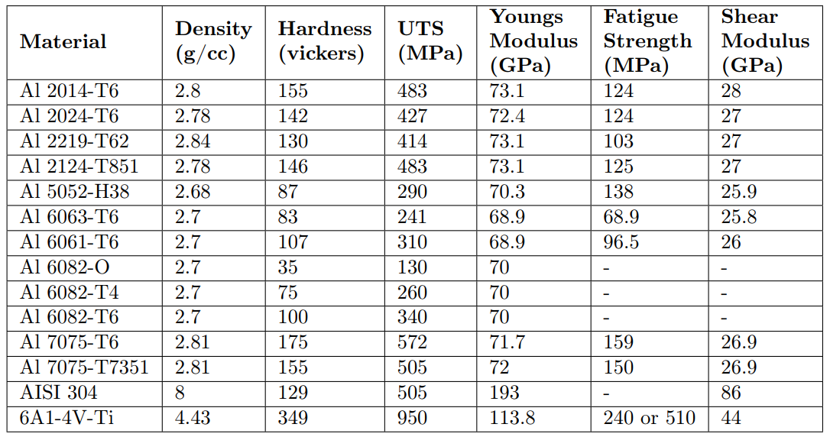

**Figure 5-8-1.**

However, it should be noted that not all of the materials above are capable of withstanding the temperatures on the Martian surface. A table of all materials that are capable of withstanding temperatures downwards of -130C are shown in Figure 5-8-2.

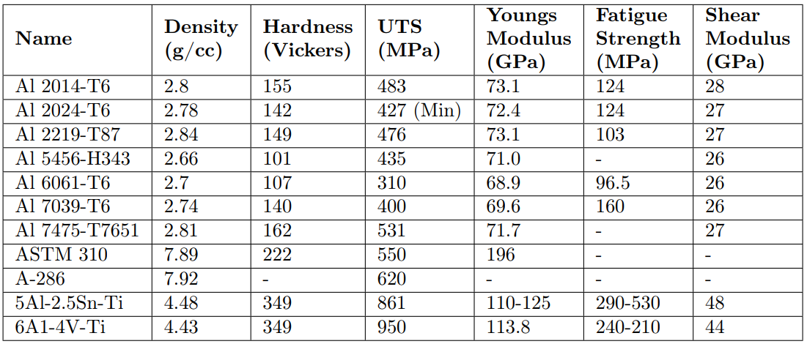

**Figure 5-8-2.**

For the purposes of the mission, it is imperative that the rover wheels maintain structural integrity over the course of the mission, which will last for an extended period of time. For this reason, the fatigue strength of the materials must be taken into special consideration, since the vibrations caused by the drill and repeated loading cycles of ice cores cause a continuous stress to the material. Since 5Al-2.5Sn-Ti is reported to have the highest fatigue strength, as well as a large tensile strength, it provides the structural integrity needed to carry out the mission. What’s more, the natural corrosive resistance of titanium alloys makes it a prime candidate for being used in the rover’s WSS.

The size and the shape of the wheels draw inspiration from NASA’s Mars 2020 Rover “Perseverance”. As such, the wheels are designed to be 52.5 cm in diameter, 25 cm in width, and a cylindrical shell width of 2.5 cm, such that one full rotation of the wheels will cause the rover to move forward about 1.65 m. The wheel design also employs the cleats employed on Perseverance’s wheels. These cleats will also be made out of 5Al-2.5Sn-Ti, as its corrosive resistance will help to preserve the control of the wheels. A CAD design of an anticipated wheel on the rover can be seen in Figure 5.5.3.

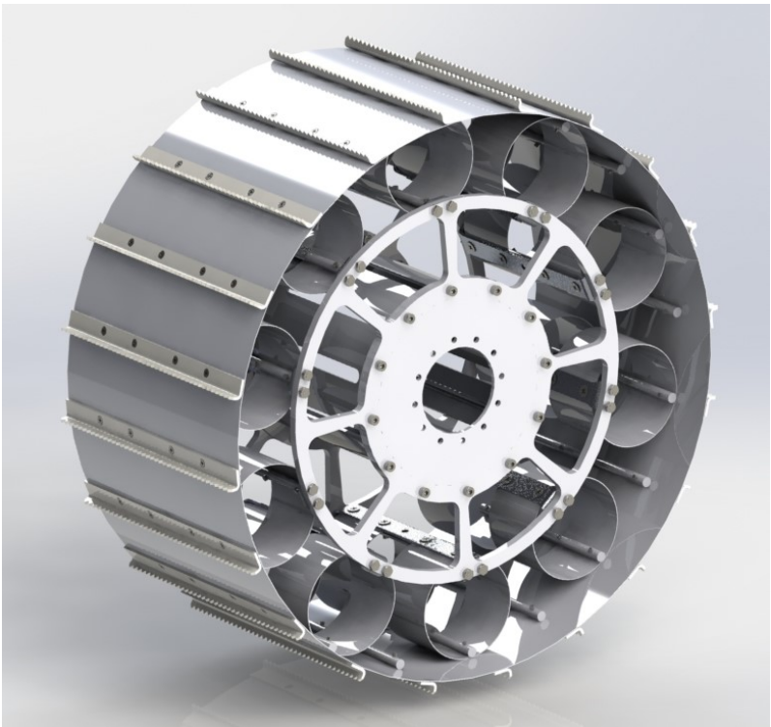

**Figure 5-8-3.** Image of rover wheels.

Finally, the suspension system of the rover is selected to be a rocker-bogie suspension, since it allows for the rover to navigate the rough terrain of the chosen SROI with ease, in addition to reducing stress on the wheels and the body itself. A CAD design of the WSS system can be seen in Figure 5.5.4 with a sample body.

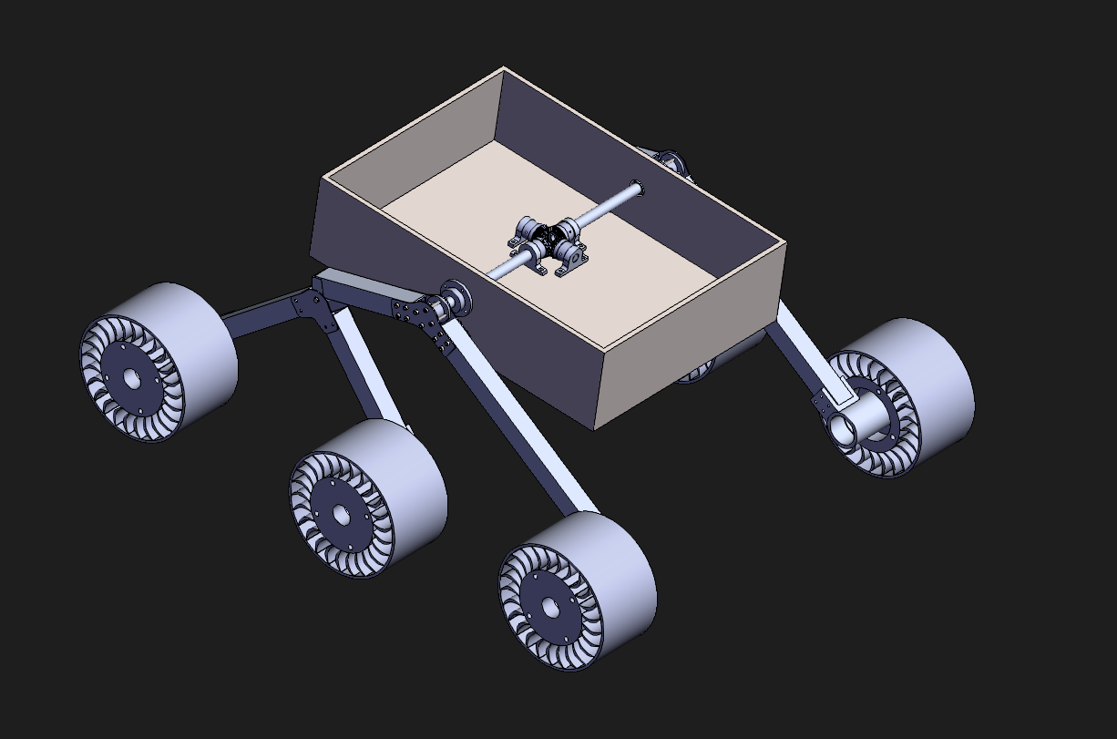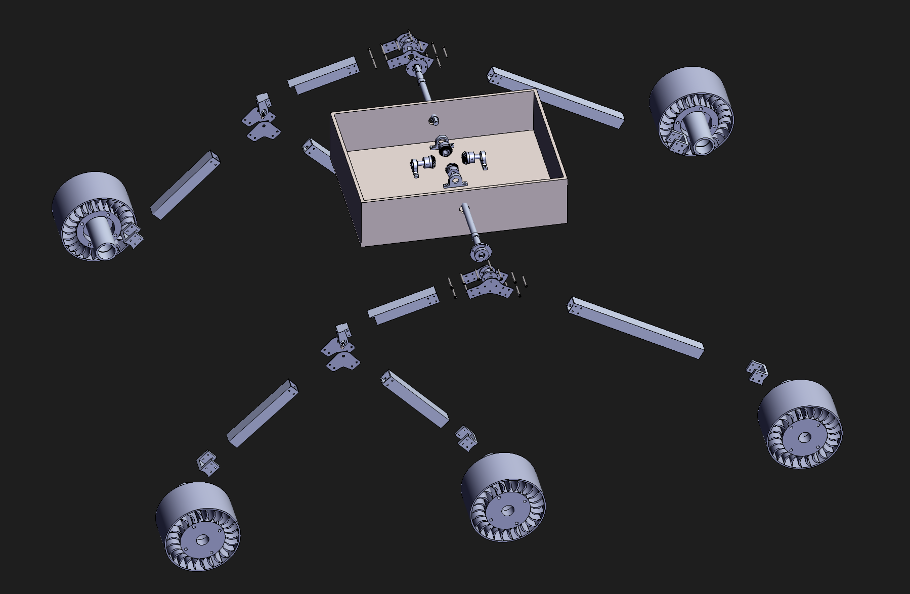

**Figure 5-8-4.** CAD Rendering of Rover Body Concept.

## 5.9 Rover Body

The rover body is a simple, yet integral part of the rover vehicle. It is responsible for protecting the hardware used for sample collection, analysis, and the basic functions of the rover. In the spirit of reusing existing hardware as stated in the mission prompt, the rover body is modeled after the rover body designs of the *Curiosity* and *Perseverance* rovers. The rover body itself is designed to have dimensions of 7 ft (2.1m) x 4 ft (1.2m) x 2 ft (0.6m), as displayed in the 3D model below.

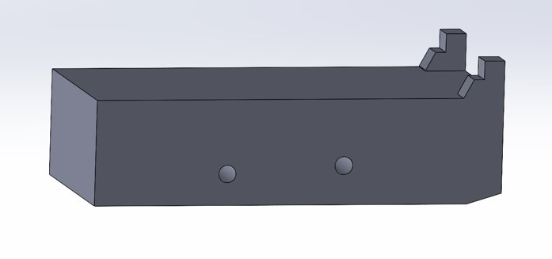

**Figure 5-9-1.** CAD design of the rover body (left side view).

The two turrets at the rear of the rover body are used as attachments for the rover’s RTG. Likewise, the two holes in the side of the body, along with their pair on the other side, are used as places where the rover’s WSS, or the rocker-bogie suspension system, hooks up to. Additionally, the sample container is located at the front of the rover body, embedded into it such that nothing protrudes from the surface.

For the material used in the rover body, referring to Table 5.8.2, the aluminum alloy Al 7039-T6 is used as it combines a relatively low density with high UTS and fatigue strength, three quantities important to a body meant to support heavy loads for an extended period of time. In addition to an aluminum alloy providing structural support, the seams in the aluminum alloy will be, in a way, caulked by Silica Aerogel, such that there is minimal heat loss within the rover.

Finally, a general overview of the mass and power budgets for the rover’s body-related components can be found in Figure 5.9.2. The total cost of these systems is also listed.

**Table 5-9-1.** Mass and Power for Rover

|  |  |  |  |
| --- | --- | --- | --- |
| **Component** | **Mass (kg)** | **Power (W)** | **Cost ($)** |
| Body | 490 | 0 | ---- |
| Wheels | 205 | 15 (continuous use for 2 km) | ---- |
| Suspension | 135 | 0 | ---- |
| Arm/Turret | 30 | 20 (in continuous use) | ---- |
| Sample Container (dry) | 12 | 0 | ---- |
| Sample Container (full) | 14.5 | 0 | ---- |
| Freon-14 Loop (dry) | 2 | 0 | ---- |
| Freon-14 Loop (full) | 7.5 | 6 (in continuous use) | ---- |
| Sample Container Lithium Battery | 1.5 | 3.5 (while charging) | ---- |
| RTG (dry) | 41.2 | 0 | ---- |
| RTG (full) | 45 | 0 | ---- |
| Drill | 7.2 | 150.45 |  |
| Electronics (Other batteries, computers, cameras) | 23.5 | 42 | ---- |
| Communications | 22.5 | 108.1 |  |
| **Maximum Total (dry)** | **969.9** | **339.05** | **490,002,543** |
| **Maximum Total (full)** | **981.7** | **345.05** | **490,016,799** |

# 6. Mars Ascent Vehicle (MAV)

## 6.1 System Overview and Subsystem Requirements

The MAV has 3 requirements during the return to Earth segment of the mission consisting of: delivering the ice samples from the Martian surface to the orbiter, preserving the ice samples during the flight from Mars to Earth, and carrying the samples within its storage cooling unit during the capsule’s transit and descent to Earth. The MAV is required to protect the samples from any form of contamination (thermal, physical, material) after leaving the rover and through the flight to Earth. To ensure that no physical contamination of the ice samples occurred due to repeated vibrations and changes in orientation, the MAV’s permanent place during the flight home was chosen on the inside of the capsule on the orbiter.. Additionally, the entire exterior of the MAV will be made of an aluminum alloy.

**Table 6-1-1.** MAV Requirements.

|  |  |  |  |
| --- | --- | --- | --- |
| **#** | **Requirement** | **Rationale** | **Traceability** |
| **MAV System Level Requirements** | | | |
| 2.00 | The MAV shall remain in a safe state during transit, descent and when the rover is conducting initial surface operations. | The MAV will need to remain in a safe state in order to not spontaneously ignite or become a danger to the rest of the rover and mission. | MO.1, MO.2 |
| 2.01 | The MAV shall receive payload from the rover. | The MAV will need to hold an appropriate position for reception of the samples from the rover arm. | MO.1, MO.2 |
| 2.02 | The MAV shall maintain adequate temperature and physical protection for the ice samples. | The MAV will need to maintain the ice core at a certain exam in order to prevent loss of payload and scientific value. | MO.1, MO.2 |
| 2.03 | The MAV shall launch from the rover in a manner where the rover is unaffected by the rocket's exhaust. | The MAV will need to launch at a location where the exhaust from the engine does not damage the rover in order for the rover left on the surface to maintain long term mission capability. | MO.1, MO.2 |
| 2.04 | The MAV shall ascend and rendezvous with the orbiter at the same altitude. | The MAV will need to achieve equivalent velocity of the orbiter for a less than 5 m/s relative velocity value. | MO.1, MO.2 |
| 2.05 | The MAV shall be brought into the capsule through the orbiter arm. | The MAV should be in reach of the capsule arm to be brought inside the capsule. | MO.1, MO.2 |
| 2.06 | The MAV shall hold and deliver the ice samples during the capsule's entry to the Earth's atmosphere. | The MAV will need to stay at an appropriate orientation during the capsule's reentry to protect the samples from heat and vibrations. | MO.1, MO.2, MO. 4 |

**6.1.2 MAV Concept of Operations**

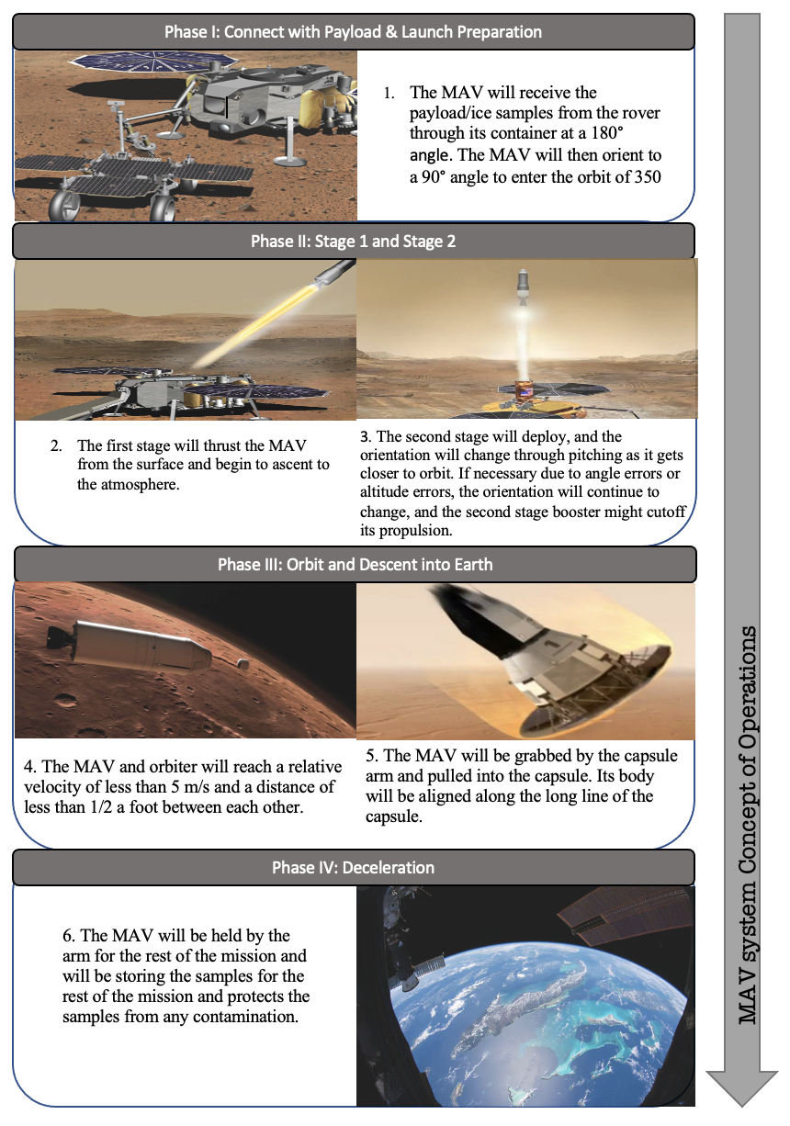

## 6.1.3 System Risk Verification and Matrix

**Table 6-1-2.** MAV Risk Assessment.

|  |  |  |  |  |  |
| --- | --- | --- | --- | --- | --- |
| **Risk** | **Description** | **Effect** | **Mitigation** | **Likelihood** | **Severity** |
| R1 | Incorrect angle for launch. | The angle changes during descent will reduce vertical velocity. | An orientation sensor will correct the launch pad’s orientation before launch after collecting ice samples from the rover. | 1.i, 1.f | 4.i, 3.f |
| R2 | Angle changes during the ascent are too small or too large. | Vertical or horizontal velocities will not be high or low enough to achieve desired orbit altitude/velocity. | 2 orientation sensors will be connected to the MAV’s navigation system. | 2.i, 1.f | 3.i, 2.f |
| R3 | Final altitude of the MAV is too high or low. | The rendezvous with the orbiter will be missed. | Engine thrust will be reduced to certain levels as altitude increases. | 1.i, 1.f | 5.i, 4.f |
| R4 | Containment unit will be damaged during Mars-Earth Transit. | Ice samples will be lost or contaminated. | The exterior will be made of aluminum alloy for external protection. | 1.i, 1.f | 5.i, 3.f |
| R5 | The MAV slips from the arms of the orbiters claw during the transit. | Physical contamination of samples. | The interior of the claws of the capsule arm will be made of rubber. | 2.i, 1.i | 5.i, 3.f |

## 

## Table 6-1-2. MAV Risk Matrix.

|  |  |  |  |  |  |  |
| --- | --- | --- | --- | --- | --- | --- |
| **MAV Risk Matrix** | | | | | | |
|  | **Severity** | | | | | |
|  |  | 1 | 2 | 3 | 4 | 5 |
| **Likelihood** | 1 (0-10%) |  | R2.f, R4.f | R5.f, R1.f | R1.i, R3.f | R3.i, R4.i |
| 2 (11-20%) |  |  | R2.i |  | R5.i |
| 3 (21-40%) |  |  |  |  |  |
| 4 (40-90%) |  |  |  |  |  |
| 5(90-100%) |  |  |  |  |  |

## 

## 6.2 Electrical Power System (EPS)

**Table 6-2-1.** MAV Electrical Power Requirements.

|  |  |  |
| --- | --- | --- |
| **#** | **Requirement** | **Rationale** |
| **MAV EPS Subsystem Level Requirements** | | |
| 6.2.1 | The EPS shall provide enough power to ensure the reliable operation of all systems on the MAV. | This mission relies on many mechanical systems to be successful; all of these systems require power. If power cannot be provided, the mission is jeopardized because the MAV will not be able to rendezvous with the orbiter and keep its sample at the correct temperature. |
| 6.2.2 | The EPS shall provide enough power to operate sample caching systems during sample retrieval. | The goal of the mission is to drill and store ice samples. Without power to operate the sample collection systems, the mission fails. |
| 6.2.3 | The EPS shall provide power to communication systems to ensure information can be sent to and received from the MAV. | If we cannot communicate with the MAV and send it instructions, the mission cannot be completed. |

The electrical power system of the MAV is responsible for maintaining all onboard electronics functional both during standby periods and active periods and maintaining the ice core sample at a correct temperature. During launch, transit and descent to the surface of Mars, the electrical power system of the MAV will be reliant on the electrical power system of the orbiter, lander and rover that it is attached to. During those standby time periods, it will use its electricity in order to conduct periodic status checks of all its onboard computers and sensors and maintain them all at a correct temperature. Once the rover is operational, the MAV will rely on its own solar panels in order to generate electricity it will use to keep its systems running. When given the option between an RTG power generator source and using solar panels, we chose to use solar panels because an RTG will cause problems when it is inserted into the capsule for descent back onto Earth. The solar panels will run the MAV’s electronics systems directly and also charge an onboard battery. The battery will power communication, guidance and navigation and thermal subsystems while it awaits rendezvous with the orbiter and during nighttime periods. This battery will be required to last a minimum of 50 days while fully charged in order to allow sufficient time for the orbiter to rendezvous with the MAV and account for any variations in launch time.

**Table 6-2-2.** Chart listing power consumption approximations.

|  |  |
| --- | --- |
| **System** | **Approximate power consumption during standard operation** |
| Ice core sample storage | ~100 watts |
| Guidance and Navigation Systems | ~100 watts |
| Communication | ~100 watts |

After the orbiter rendezvous and the MAV goes inside the Earth descent capsule, the MAV will once again be reliant on another subsystem to acquire power to run its subsystems. From rendezvous until Earth orbital insertion, the battery of the MAV will be charged by the orbiter. Once the Earth descent capsule with the MAV inside separates and descends back onto Earth, the MAV will rely on its battery to maintain communication, guidance and navigation and thermal subsystems running until it is recovered at splashdown.

## 6.3 Communications

**Table 6-3-1.** MAV Communications Requirements.

|  |  |  |
| --- | --- | --- |
| **#** | **Requirement** | **Rationale** |
| **MAV COMMS Subsystem Level Requirements** | | |
| 6.3.1 | The MAV’s communication system shall transmit data and communicate with the orbiter. | The orbiter will serve as a midpoint between all communication between the MAV and Earth. |
| 6.3.2 | The MAV’s communication system shall contain a high gain antenna and a X band antenna. | A X band antenna will be used for more than half of all communications transferred for orbiter-to-Earth communication. |
| 6.3.3 | The MAV communications shall be able to use other subsystem communications systems to communicate | The MAV has a relatively weak communication system and relies on other subsystems to communicate with Earth. |

In order to transmit data and perform periodic system checks from the MAV, a reliable communication system must be placed on the MAV. Two main antennas will be utilized by the MAV which include an X-band antenna for communication between the MAV and the orbiter and a second ultra-high frequency (UHF) antenna as a backup system.

**Table 6-3-2.** MAV Data Budget per period.

|  |  |  |
| --- | --- | --- |
| **Subsystem** | **Component** | **Data Return** |
| PAY | Guidance and Navigation Cameras | 70 MB |
| PAY | Sample Caching Camera | TBD |
| PAY | Ground radar instrument | 0.01 MB |
| PAY | System checks | 100 MB |
|  | Total Data Return per day | $⩰$ 200 MB |

The orbiter is used as a relay for transmitting data between the MAV and Earth. Since the MAV will operate independently for a short amount of time when compared to the entire mission timeline and the numerous autonomous commands it will perform, it will not require an antenna onboard to directly communicate to Earth. From launch until descent onto Mars, the MAV will conduct its communications through the orbiter. From descent onto Mars until launch and rendezvous, the MAV will communicate independently with its antennas. Once inside the capsule on the orbiter, it will rely on the orbiter for communications. Once it separates from the orbiter for descent onto Earth, it will once again communicate independently.

## 6.4 Guidance, Navigation, and Control

**Table 6-4-1.** GNC Requirements.

|  |  |  |
| --- | --- | --- |
| **#** | **Requirement** | **Rationale** |
| **MAV GNC Subsystem Level Requirements** | | |
| 6.4.1 | The first stage of the MAV shall detach at an altitude of 75000 m with a 100m margin of error. | The MAV will use the altitude sensors to determine the appropriate time to detach the first stage. |
| 6.4.2 | The MAV shall be at a horizontal orientation at orbit altitude with a 1 to 2 degree margin of error. | The MAV will change its orientation at selected altitudes during the ascent. |
| 6.4.3 | The MAV shall be at a horizontal velocity of 3377 m/s at orbit altitude with 5 m/s margin of error. | The MAV will need to increase its horizontal velocity during ascent with its pitching maneuvers. |

**6.4.1 Propulsion Stages**

To achieve a relative velocity of < 5 m/s for a smooth rendezvous with the orbiter, an appropriate final velocity of 3377 m/s is required for a martian orbit of 350 km. Due to orbital velocity being directly proportional to the square root of the planet’s gravity, the lower gravity value of Mars will require a lower orbital velocity compared to an Earth orbit of the sma altitude. During the ascent, the orientation of the MAV will change at selected altitudes by a certain angle. Figure 6-4-1 illustrates the change in gravity as a function of altitude.

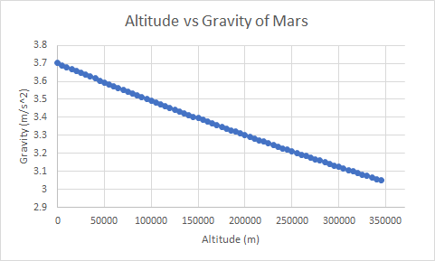

**Figure 6-4-1.** Gravity of Mars versus altitude from surface level.

Because of the higher derivative magnitudes on the far left, the changes in gravity are highest early in the ascent, therefore the first stage of the MAV will be the primary source of thrust. At an altitude of 75000 m, stage 1 will cutoff and the second stage will ignite. With smaller gravity changes at these altitudes, the second stage will focus more on orientation instead of overcoming significant gravity values.

**6.4.2 Ascent Maneuvers**

To avoid significant aerodynamic stresses on the MAV, the orientation of the MAV will begin to change at a height of 1 km from the surface while the delta V is still relatively small. 3 small nozzles releasing pressurized air will be placed at the top of the MAV to provide a larger torque for each angle maneuver. The orientation changes for each altitude stage occur at a constant rate of change until the specified angle is achieved at its respective altitude. For each orientation there exists an allowable margin of error of ½ degrees while the altitude margin of error is 25 meters above and below the altitude values in Table 6-4-2.

**Table 6-4-2.** Maneuvers and Angle Changes of MAV during Ascent.

|  |  |  |
| --- | --- | --- |
| **Start Pitching** | 1 | km |
| **Angle 1** | 30 | degrees |
| **Occurs at** | 55 | km |
| **Stage 1 Engine Cutoff** | 75 | km |
| **Angle 2** | 60 | degrees |
| **Occurs at** | 150 | km |
| **Angle 3** | 75 | degrees |
| **Occurs at** | 250 | km |

The horizontal component of the velocity will begin to increase during the second stage since more orientation angles will be changed in shorter altitude intervals. Resultantly, the 60 degree angle orientation will be set for a longer distance interval to avoid reducing the horizontal component buildup or the vertical component of the instantaneous velocities.

## 6.5 Payload and Main Components

**Table 6-5-1.** Payload Requirements.

|  |  |  |
| --- | --- | --- |
| **#** | **Requirement** | **Rationale** |
| **MAV Payload Subsystem Level Requirements** | | |
| 6.5.1 | The payload shall have minimal heat transfer across the walls of the insulator. | The walls will need to be made of fiberglass across all sides of the containment unit. |
| 6.5.2 | The payload shall stop physical contamination of the ice samples. | The fiberglass insulator should be pointed inwards since the glass will not absorb water. |
| 6.5.3 | The payload shall prevent continuous movement of the ice samples. | The payload shall maintain the ice samples perpendicular to the containment's surface. |

### 6.5.1 Main Components

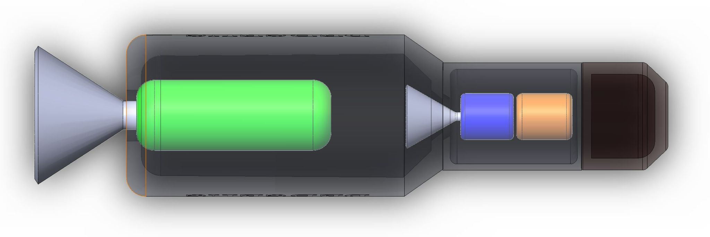

**Figure 6-5-1.** Transparent 3D model of MAV.

Figure 6.5.1 depicts the transparent overall design of the MAV. A 2 stage rocket design, the 1st thrust section is a solid rocket booster using an ammonium perchlorate composite propellant. The second stage, a liquid rocket design, will utilize hydrazine which will be stored in both tanks shown in the second stage of Figure 6.5.1. A liquid rocket setup was chosen for the second stage due to the various orientation changes which would include a higher risk of error using a solid rocket as well as the risk of too high or low thrust at critical points along the ascent. Additionally, there exists a possible need for engine temporary cutoff if velocity exceeds the necessary magnitude.

The shell of the MAV will be 7 cm thick with the exterior made out of aluminum alloy metals with a total mass of 2500 kg.

**Table 6-5-1.** Dimensions and Mass of the MAV.

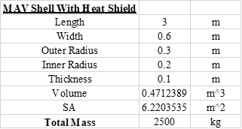

Both nozzles of the stages will be made of aluminum using the ambient temperature as the cooling system for each stage. Due to the initial surface temperature of Mars being significantly low at night time, the lower ambient temperatures will be used as the cooling for the nozzle.

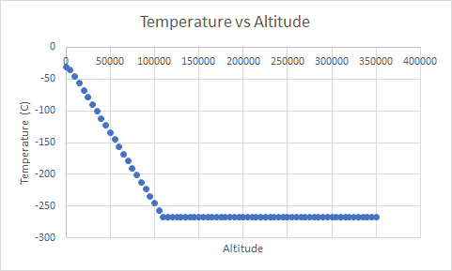

**Figure 6-5-2.** Temperature vs Altitude from the Surface of Mars.

By the time the second stage is expected to start, the ambient temperature stays almost constant until orbit altitude is reached.

**6.5.2 Payload**

The rover’s sample containment unit will be placed near the top of the MAV underneath the pressurized air storage for the launch maneuvers. The interior of the sides of the container will be composed of fiberglass due to its inability to absorb water preventing physical contamination of the samples at any moment. The fiberglass is attached to the aluminum shell of the MAV with the dimensions of the containment being as small as possible to avoid damage to the sample storage or the samples themselves due to vibrations. Since no delivery of samples from the MAV to other vehicles is expected, no easily opened doors or lids will be placed around the storage unit.

# 7. Orbiter

## 7.1 System Overview and Subsystem Requirements:

The orbiter carries the rover, lander, and MAV to Mars safely. It will need to maneuver itself and keep track of its position the whole time. It must also have the ability to communicate with the DSN and the MRO to return data to the rover and to Earth.

**Table 7-1-1.** Orbiter Requirements.

|  |  |  |  |
| --- | --- | --- | --- |
| **#** | **Requirement** | **Rationale** | **Traceability** |
| **Orbiter System Level Requirements** | | | |
| 1.01 | The orbiter shall be able to navigate to Mars. | The orbiter will carry the rover, lander, and MAV to Mars. | MO.1 |
| 1.02 | The orbiter shall undergo deep space maneuvers if trajectory adjustments are needed. | Deep space maneuvers are sometimes needed to rendezvous with the target. The orbiter must be capable of making them mid-flight. | MO.1 |
| 1.03 | The orbiter shall be able to perform the maneuvers to transfer into Martian orbit. | The orbiter needs to change its flight path from hyperbolic to circular. | MO.1 |
| 1.04 | The orbiter shall be able to tell its position relative to Earth and Mars from its own instruments. | The orbiter must relay positional data back to Earth for tracking purposes. | MO.1 |
| 1.05 | The orbiter shall remain in orbit for the duration of the ground mission. | The orbiter needs to catch the samples when the ground mission is concluded and keep an eye on the rover in the meantime. | MO.7 |
| 1.06 | The orbiter shall recapture the samples upon completion of the ground mission. | The orbiter will contain the mechanisms to capture the samples and return them to Earth. | MO.11 |
| 1.07 | The orbiter shall navigate back to Earth with the samples. | The orbiter will leave its circular orbit and enter a hyperbolic flight path. | MO.1 |

### 

### 7.1.2 Orbiter Concept of Operations:

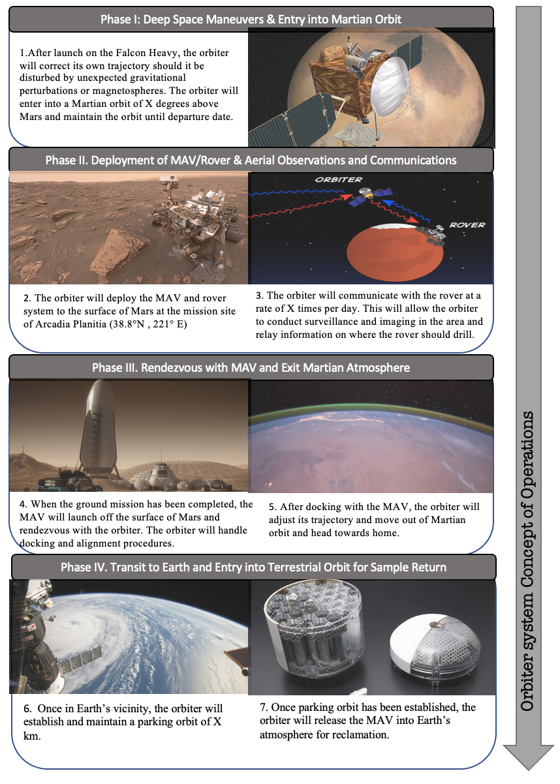

**Table 7-1-2.** Orbiter Risk Assessment.

|  |  |  |  |  |  |
| --- | --- | --- | --- | --- | --- |
| Risk | Description | Effect | Mitigation | Likelihood | Severity |
| R1 | Launch gets delayed beyond November 2026. | Energy required to get to Mars increases significantly. | Allow multiple launch dates within the window of Oct 31-Nov 19 2026. | 1.i, 1.f | 3.i, 2.f |
| R2 | Trajectory towards Mars misses the target. | Significant delay of mission and possible loss of vehicle. | Thrusters allow for correction burns. | 3.i, 2.f | 5.i, 5.f |
| R3 | Delta-v for Martian capture does not meet 2.127 $km/\sec^{2}$. | Potential loss of vehicle. | Ensure thrusters have power outputs meeting that needed for capture. | 3.i, 1.f | 4.i, 4.f |
| R4 | MAV/Rover system deploys and lands outside of the target area. | Loss of samples. | Scout area before deployment using on-board sensors. | 2.i, 1.f | , 5.f |
| R5 | MAV will fail to rendezvous with Orbiter | Potential loss of both systems | Orbiter equipped with sensors to maneuver and capture MAV | 3.i, 1.f | 4.i, 5.f |
| R6 | Trajectory towards Earth misses the target | Potential loss of vehicle | Correction burns will be executed by the thrusters. | 3.i, 2.f | 5.i, 5.f |
| R7 | Samples are not properly relinquished to Earth | Loss of samples | Rendezvous with the ISS will be used as needed. | 3.i, 2.f | 5.i, 5.f |

**Table 7-2-3.** Orbiter Risk Matrix.

|  |  |  |  |  |  |  |
| --- | --- | --- | --- | --- | --- | --- |
| **Orbiter Risk Matrix** | | | | | | |
|  | **Severity** | | | | | |
|  |  | 1 | 2 | 3 | 4 | 5 |
| **Likelihood** | 1 (0-10%) |  | R1.f | R1.i | R3.f | R4.f |
| 2 (11-20%) |  |  |  |  | R2.f, R4.i, R6.f, R7.f |
| 3 (21-40%) |  |  |  | R3.i | R2.i, R5.f, R7.i |
| 4 (40-90%) |  |  |  |  | R5.i, R6.i |
| 5 (90-100%) |  |  |  |  |  |

## 7.2 Propulsion

**Table 7-2-1.** Orbiter ADCS Subsystem level requirements.

|  |  |  |
| --- | --- | --- |
| **#** | **Requirement** | **Rationale** |
| **Orbiter ADCS Subsystem Level Requirements** | | |
| 7.2.1 | The propulsion system shall provide the required delta- V changes throughout the duration of the mission. | The orbiter will conduct maneuvers. |
| 7.2.2 | The propulsion system shall move the spacecraft into and out of Martian orbit. | Precise orbital locations are needed for surface operation deployment. |

In determining the propulsion system aboard the orbiter, three different types of propulsion were considered: chemical, electric, and a chemical-electric hybrid system. Chemical propulsion systems are by far the most mature and developed of propulsion systems, with relatively low risk and plenty of prior use. These systems can provide high levels of thrust, allowing for quick and easy orbital maneuvers. However, chemical propulsion systems have lower specific impulse, requiring large amounts of propellant that increases both cost and mass. Electric propulsion systems on the other hand provide major mass savings in comparison with chemical propulsion systems, but have much lower thrust levels that are limited by the efficiency of solar arrays. The particular electric propulsion system considered for this mission is NASA’s Solar Electric Propulsion system, which utilizes a combination of solar arrays and Hall Effect Thrusters to provide low burn thrust for spacecraft.

This mission in particular requires that the Mars sample be returned to Earth by 2030, providing a limited time frame for transit to mars, martian surface operations, and the return. Because of this limited time frame, we determined that a completely electric propulsion system would not be feasible given the time frame. Since an aerobraking technique is not being used for orbit insertion, an all-electric propulsion system would require the use of a slow spiral orbital transfer as the spacecraft lowers into its 350 km circular orbit, which requires too much time. However, a hybrid chemical-electric propulsion system, although appealing due to its potential mass savings, would complicate the system and increase the likelihood of failure. With the large delta-v required to lower into the desired circular orbit at 350 km, a chemical propulsion system is best suited to provide this required delta-v in a timely, low-risk manner.

The propulsion system is required to provide the necessary delta-v to take the orbiter from low-earth orbit into martian orbit, and to then return back to earth with the samples collected at Mars. The calculated mission delta-v requirements are found in the table below. The propulsion system will consist of two different thruster types: larger thrusters for the main orbit insertion burns and smaller thrusters for trajectory correction maneuvers.

**Table 7-2-2.** Delta-V Analysis.

|  |  |
| --- | --- |
| **Phase** | **Delta-V (km/s)** |
| LEO to Mars | 3.611 |
| Mars Orbit Insertion | 2.127 |
| Mars to Earth | 2.04 |
| Earth Orbit Insertion | 3.524 |

The larger chemical thrusters selected for the orbiter are Aerojet Rockedyne’s R-42 rockets, which have a steady state thrust of 890 N and a specific impulse of 302 seconds. The orbiter will have three of these thrusters (2 actual, 1 redundant), which will provide the required delta-v changes when performing major orbital maneuvers, such as the Mars orbital insertion, which has a delta-v requirement of 2.127 km/s, and the Earth orbital insertion, which has a delta-v requirement of 3.524 km/s. Upon arrival at Mars, these thrusters will operate for 5.62 hours during the orbit insertion phase and bring the spacecraft into its desired circular orbit. This thruster uses MMH/NTO as propellant, which has a propellant density of 1139 kg/m3.

The smaller chemical thrusters selected for the orbiter are Aerojet Rocketdyne’s R-6F Bipropellant thrusters. These thrusters use the same bipropellant fuel as the R-42 thrusters, which enables the use of the propellant tank. These thrusters have a steady state thrust of 25 N with a specific impulse of 305 s. There will be six of these R-6F thrusters, which will provide the necessary trajectory correction during the transit to and from Mars.

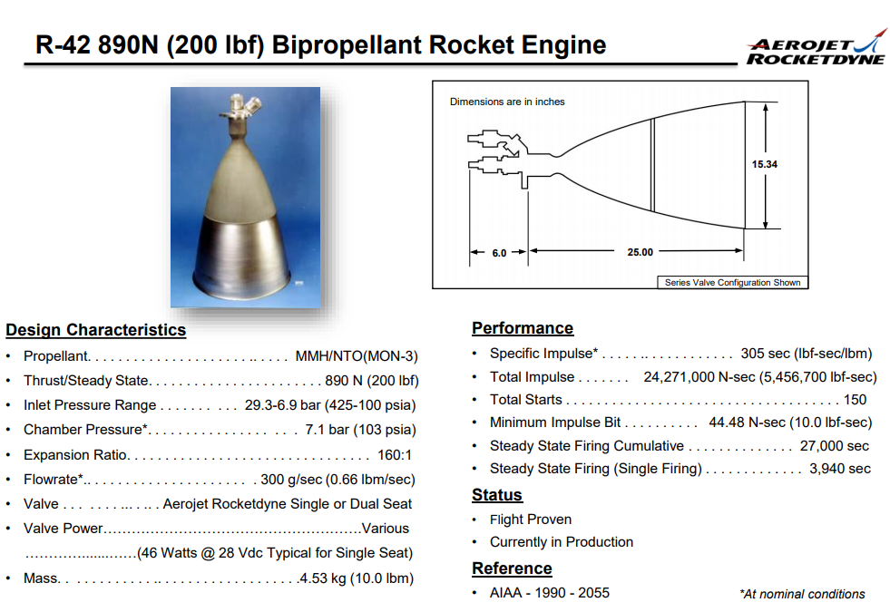

**Figure 7-2-1.** Rocket Engine Considerations (1).

The smaller chemical thrusters selected for the orbiter are Aerojet Rocketdyne’s R-6F Bipropellant thrusters. These thrusters use the same bipropellant fuel as the R-42 thrusters, which enables the use of the propellant tank. These thrusters have a steady state thrust of 25 N with a specific impulse of 305 s. There will be six of these R-6F thrusters, which will provide the necessary trajectory correction during the transit to and from Mars.

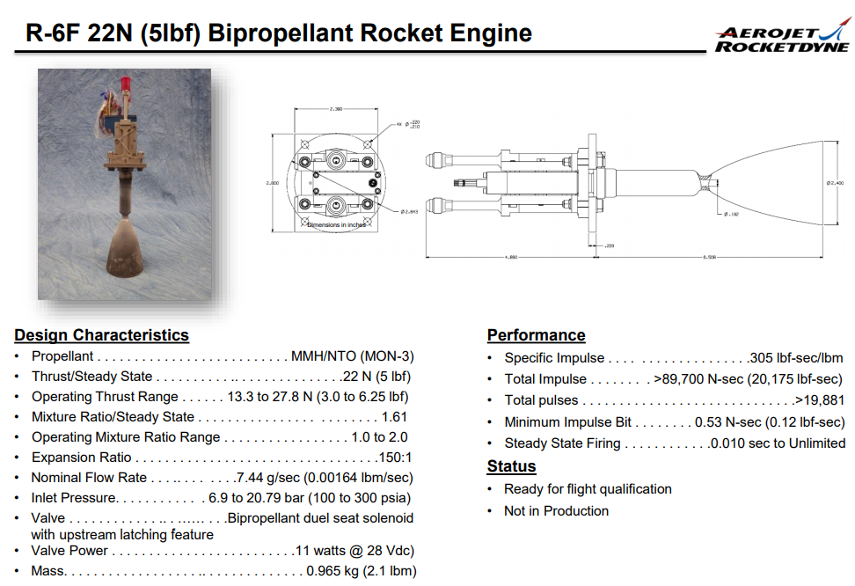

**Figure 7-2-2.** Rocket Engine Considerations (2)

The total fuel requirement is 7900, which given the density of the bipropellant in use, requires an overall fuel tank mass of 790 kg.

## 7.3 Electrical Power System

To power the orbiter, two 10 m^2 multi-junction photovoltaic solar arrays will be used to provide 1451 watts of power while in view of the sun, providing sufficient power for both operation and battery recharge. The orbiter will be equipped with three 50Ah lithium-ion batteries in order to provide the necessary power requirements while the orbiter is not in view of the sun.

The power budget of each subsystem can be found below.

**Table 7-3-1.** Power Budget for Orbiter.

|  |  |
| --- | --- |
| **System** | **Power (Watts)** |
| Propulsion | 90 |
| ADCS | 6 |
| COMM | 359 |
| PAY | 200 |
| CDH | 20.5 |
| EPS | 50 |
| TOTAL: | 725.5 |

## 7.4 Communications

The orbiter will be in charge of relaying information between Earth and the rover on the surface of Mars. In order to accomplish this, the orbiter is equipped with an identical system to the Mars Reconnaissance Orbiter, which contains X-band, Ka-band, and UHF antennas and communication systems to provide relay between Earth and Mars. The X-band The communications system has an overall power requirement of 359 W, as well as a system mass of 107.7 kg.

## 7.5 Attitude Determination and Control System

**Table 7-5-1.** Orbiter ADCS Requirements.

|  |  |  |
| --- | --- | --- |
| **#** | **Requirement** | **Rationale** |
| **Orbiter ADCS Subsystem Level Requirements** | | |
| 7.5.1 | The ADCS subsystem shall stabilize and orient the spacecraft. | The orbiter will navigate the rover and MAV to Mars and back. |
| 7.5.2 | The ADCS subsystem shall orient the spacecraft towards the sun. | The orbiter is partially powered by solar arrays and needs to find the Sun to power itself. |
| 7.5.3 | The ADCS subsystem shall manage orbital maneuvers. | The orbit the spacecraft enters Mars in will more than likely not have the exact inclination needed. |

Attitude Determination and Control of the orbiter stabilizes and orientates the spacecraft the correct way to keep it on path to Mars in the timeframe specified. The journey to Mars only takes around 9 months in our case. To make a timely arrival to Mars, disturbances such as perturbations in gravity, magnetic disruptions and solar particles need to be handled by the spacecraft itself.

Since the spacecraft is partially powered by solar arrays, they will need to be kept towards the Sun. This means the orbiter will have to have a sun sensor and 3-axis control. This is good for a number of reasons, one being the distance between Earth and Mars means communication requires more accurate pointing of the spacecraft, and 3-axis control will allow the orbiter to better image the rover during ground operations.

Thrusters and reaction wheels will be used for the control because gravity-gradient and magnetic torquing are insufficient for the orbit around Mars. Mars has a very small magnetic field, so magnetic torquing is of little use during the orbiter's time in Martian orbit. Thrusters will be able to produce a large torque, which is necessary for the orbit changes once in Martian orbit. The orbiter will not reach Mars in its desired orbit, and an inclination change must be made. Therefore, thrusters can be used in this case to determine attitude. The reaction wheels are in place because they use much less propellant than thrusters, and can thus be used for minor disturbances acting on the spacecraft. Although these produce less torque than the thrusters, they will be sufficient in counteracting minor disturbances such as those due to gravitational perturbations. In addition, thrusters are required to perform successful rendezvous with the MAV when the time comes for sample collection and the return trip.

The sensors required for this control system usually include Sun sensors, star trackers, and reaction wheels. The orbiter will contain a Sun sensor to be sure that the solar array receives power. This implies that the orbiter will have two Sun sensors, in case of failure in the main sensor. Since the solar array is necessary for the power requirements of the vehicle, there is no room to lose the Sun sensor. The orbiter will also include star trackers as backup systems in case of failure of the reaction wheels.

To control the attitude, the spacecraft will use its thrusters that are already installed. The thrusters are necessary for inclination change once on Mars, rendezvous with the MAV, and exit from Martian orbit. Therefore, the only additional cost of using the thrusters is additional propellant carried with the spacecraft to Mars.

To save propellant, the thrusters will be used as a backup in case of failure of any other control systems. Instead, the main control will come from reaction wheels. These typically only weigh from 2-20 kg, which is comparably less than the propellant that would’ve been needed without them.

**8. Cost Work Breakdown Structure**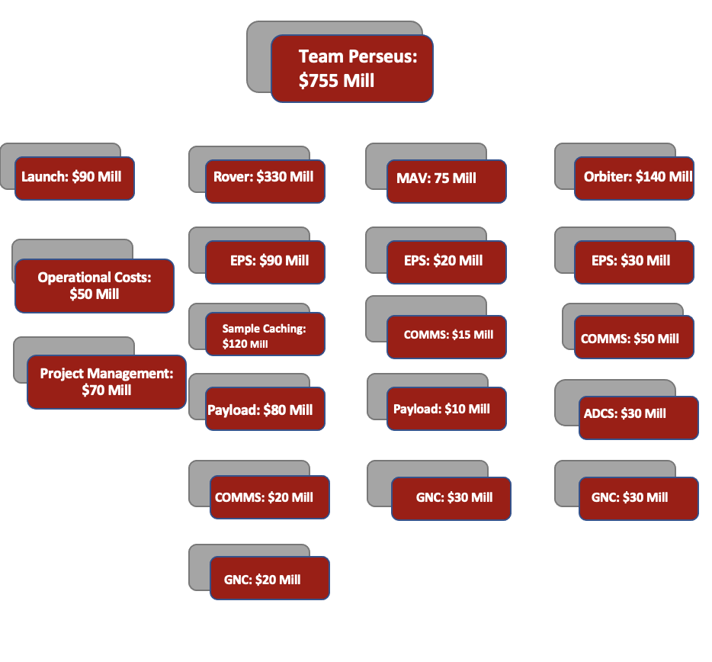

The following is the finalized work breakdown structure for the system totalling up to $755 Million for the entire mission.

References

[1] “Space Communications with Mars.” *Astrosurf*, www.astrosurf.com/luxorion/qsl-mars-communication3.htm. Accessed 14 Apr. 2021.

[2] Peterson, Peter Y., et al. “Overview of NASA’s Solar Electric Propulsion Project.” *Jet Propulsion Laboratory,* Sept. 2019. <https://www.researchgate.net/publication/269208184_Overview_of_the_Development_of_the_Solar_Electric_Propulsion_Technology_Demonstration_Mission_125-kW_Hall_Thruster>

[3] Viola, Donna, et al. “Arcadia Planitia: Acheron Fossae and Erebus Montes.” *NASA.Gov*, www.nasa.gov/sites/default/files/atoms/files/viola_arcadiaplanitia_final_tagged.pdf. Accessed 5 May 2021.

[4]Miotla, Dennis. “Assessment of Plutonium-238 Production Alternatives.” *Energy.Gov*, 21 Apr. 2008, [www.energy.gov/sites/prod/files/NEGTN0NEAC_PU-238_042108.pdf](http://www.energy.gov/sites/prod/files/NEGTN0NEAC_PU-238_042108.pdf).

[5] Benson, Tom. “Ideal Rocket Equation.” *NASA*, 13 May 2021, [www.grc.nasa.gov/www/k-12/rocket/rktpow.html](http://www.grc.nasa.gov/www/k-12/rocket/rktpow.html).

[6] Benson, Tom. “Rocket Thrust Equations.” *NASA*, 13 May 2021, [www.grc.nasa.gov/www/k-12/rocket/rktthsum.html](http://www.grc.nasa.gov/www/k-12/rocket/rktthsum.html).

[7] Kluever, Craig. “Exhaust Velocity - an Overview | ScienceDirect Topics.” *Science Direct*, 2003, [www.sciencedirect.com/topics/earth-and-planetary-sciences/exhaust-velocity#:%7E:text=Specific%20impulse%20is%20the%20length,e%20%3D%20g0Isp](http://www.sciencedirect.com/topics/earth-and-planetary-sciences/exhaust-velocity#:%7E:text=Specific%20impulse%20is%20the%20length,e%20%3D%20g0Isp).

[8] Burke, Laura M., et al. “Interplanetary Mission Design Handbook: Earth-to-Mars Mission Opportunities 2026 to 2045”. *NASA,* Oct. 2010. <https://ntrs.nasa.gov/api/citations/20100037210/downloads/20100037210.pdf>

[9] Bate, Roger, et al. *Fundamentals of Astrodynamics (Dover Books on Aeronautical Engineering)*. 1st ed., Dover Publications, 1971.

[10] Ishimatsu, Takuto. “Interplanetary Trajectory Analysis for 2020-2040”. *Massachusetts Institute of Technology*. May 2008. <https://dspace.mit.edu/handle/1721.1/45216>

[11] ] Taylor, Jim, et al. “Mars Exploration Rover Telecommunications.” *Descanso JPL NASA*, Oct. 2005, descanso.jpl.nasa.gov/DPSummary/MER_article_cmp20051028.pdf.

[12] “Talking to Martians: Communications with Mars Curiosity Rover.” *Sandilands Info*, sandilands.info/sgordon/communications-with-mars-curiosity. Accessed 28 Apr. 2021.

[13] “Sample Return Capsule.” *Spaceflight 101*, spaceflight101.com/osiris-rex/osiris-rex-sample-return-capsule. Accessed 25 Apr. 2021.

[14] Muirhead, B. K., et al. “Sample Retrieval Lander Concept for a Potential Mars Sample Return Campaign.” *Ninth International Conference on Mars 2019*, www.hou.usra.edu/meetings/ninthmars2019/pdf/6369.pdf. Accessed 24 Apr. 2021.

[15] Greicius, Tony. “NASA’s Treasure Map for Water Ice on Mars.” *NASA*, 11 Dec. 2019, [www.nasa.gov/feature/jpl/nasas-treasure-map-for-water-ice-on-mars](http://www.nasa.gov/feature/jpl/nasas-treasure-map-for-water-ice-on-mars).

[16] Viola, Donna, et al. “Arcadia Planitia: Acheron Fossae and Erebus Montes Workshop Abstract #1011.” *NASA*, www.nasa.gov/sites/default/files/atoms/files/viola_arcadiaplanitia_final_tagged.pdf. Accessed 25 Feb. 2021.

[17] “Landing Sites of Mars Missions.” *Deutsches Zentrum Für Luft- Und Raumfahrt German Aerospace Center*, [www.dlr.de/content/en/images/2020/3/landing-site-mars-mission.html](http://www.dlr.de/content/en/images/2020/3/landing-site-mars-mission.html).

[18] Hoffman, Stephen. “‘Mining’ Water Ice on Mars.” *NASA*, July 2016, mars.nasa.gov/mro/mission/instruments/hirise

[19] Horne, Mera Fayez. “Drilling on Mars - Mathematical Model for Rotary-Ultrasonic Core Drilling of Brittle Materials.” *Escholarship.Org*, escholarship.org/content/qt6zg2x2d8/qt6zg2x2d8_noSplash_340949cd6c5774667321926f9e5195d7.pdf. Accessed 24 Feb. 2021.

[20] “Mars Perseverance Press Kit.” *NASA JPL*, www.jpl.nasa.gov/news/press_kits/mars_2020/download/mars_2020_landing_press_kit.pdf. Accessed 18 Feb. 2021.

[21] Zacny, K. A. “Strategies for Drilling on Mars.” *ResearchGate*, University of California, Berkeley, California, 15 Jan. 2005, [www.researchgate.net/publication/237276557_Strategies_for_Drilling_on_Mars](http://www.researchgate.net/publication/237276557_Strategies_for_Drilling_on_Mars).

[22] Zacny, Kris. “Mobile In Situ Water Extractor (MISWE) for Mars, Moon, and Asteroids In Situ Resource Utilization.” *Aerospace Research Central*, AIAA Space 2012 Conference & Exposition, 13 Sept. 2012, arc.aiaa.org/doi/abs/10.2514/6.2012-5168.

[23] Glass, B. J. “Automated Mars Drilling for ‘Icebreaker.’” *ResearchGate*, NASA Ames Research Center, 15 Apr. 2011, [www.researchgate.net/publication/224228967_Automated_Mars_drilling_for_Icebreaker](http://www.researchgate.net/publication/224228967_Automated_Mars_drilling_for_Icebreaker).

[24] Staehle, Robert. “Mars Polar Ice Sample Return Mission.” *Research Gate*, California Institute of Technology, 12 Oct. 1976, [www.researchgate.net/publication/234549500_Mars_polar_ice_sample_return_mission_I](http://www.researchgate.net/publication/234549500_Mars_polar_ice_sample_return_mission_I).

[25] “Spacecraft Battery System Provider | Space Vehicle Battery.” *Eaglepicher*, www.eaglepicher.com/markets/space/space-exploration. Accessed 15 May 2021.

[26] Zacny, K., Y. Bar-Cohen, et al. “Drilling Systems for Extraterrestrial Subsurface Exploration.” *Astrobiology*, vol. 8, no. 3, 2008, pp. 665–706, doi:10.1089/ast.2007.0179.

[27] Zacny, K., G. Paulsen, et al. “Reaching 1 m Deep on Mars: The Icebreaker Drill.” *Astrobiology*, vol. 13, no. 12, 2013, pp. 1166–98, doi:10.1089/ast.2013.1038.

[28] Zacny, Kris. “Methods for Cuttings Removal from Holes Drilled on Mars.” *The Mars Journal*, vol. 3, 2007, pp. 42–56, doi:10.1555/mars.2007.0004.

[29] Zacny, K., et al. “ROPEC – ROtary PErcussive Coring Drill for Mars Sample Return.” *42nd Aerospace Mechanisms Symposium*, 2014, pp. 195–210, esmats.eu/amspapers/pastpapers/pdfs/2014/chu.pdf.

[30]Mars.Nasa.Gov. “CTX.” *NASA Mars*, mars.nasa.gov/mro/mission/instruments/ctx. Accessed 15 May 2021.